

Course materials

Digital twin documentation
Key concept for product development

Status: Jun 2026

Author: Dr. K. Krettenauer
C. Schmid
B. Geibel

Table of Contents
0 Model analysis with task 3
1 Open Siemens NX MCD, import the project, and save it 6
2 Definition of rigid bodies 10
3 Definition of collision body 12
4 Testing and simulating the current status 15
5 Creating connections – defining the sliding joints 16
6 Testing and simulating the current status 20
7 Implementation of position monitoring on actuators 21
8 Integration of transport surfaces 24
9 Interim test of actuators (cylinders and conveyor belt) 26
10 Integration of end position monitoring on actuators 30
11 Function test of end position monitoring on actuators 33
12 Integration of buttons in the NX model 35

Model analysis with task

The NX model used for this exercise contains two pneumatic cylinders and a conveyor belt.
The task of the system is to first push a workpiece (rectangular body) laying on a plate with two pneumatic cylinders and then transport the workpiece away using the conveyor belt.

An additional start button can be used to initiate a sequence of steps for the sequence control. The double-acting pneumatic cylinders are controlled via solenoid valves and their position is monitored by limit switches.
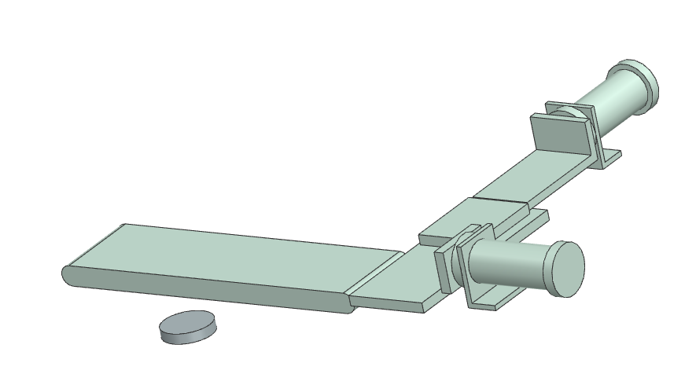
Start button
Cylinder 1
Cylinder 2
Conveyor belt
Workpiece

In the following work process, the already existing CAD model (assembly in STEP file format ) is imported to Siemens NX MCD .
Parts of it will be made „physically“ movable so that the model can then be linked to a control system (PLC SIM advanced) and the associated programming environment (TIA-Portal) .
The whole work process is devided into five sections.
1
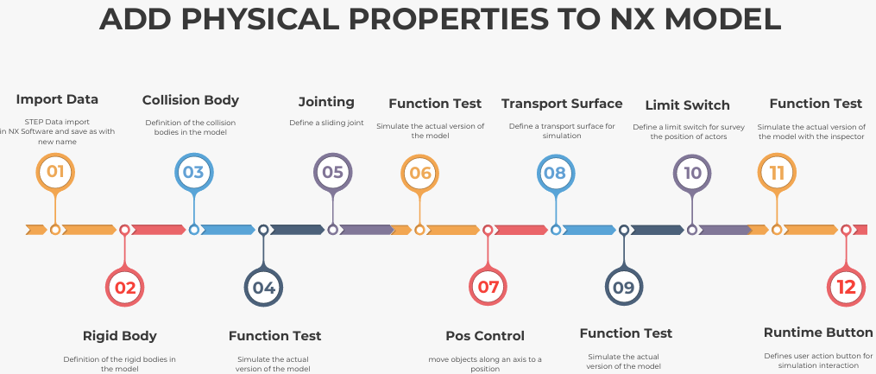
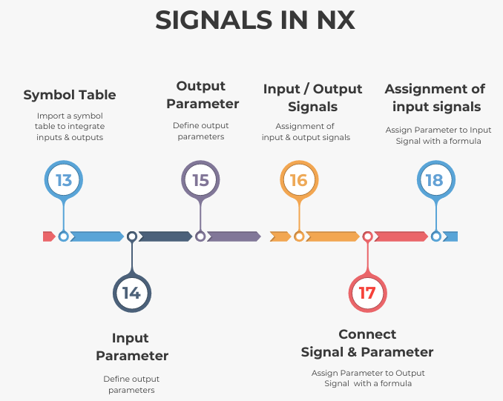
2
3
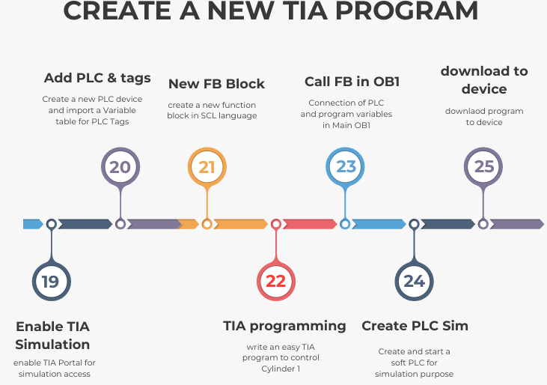

5
4
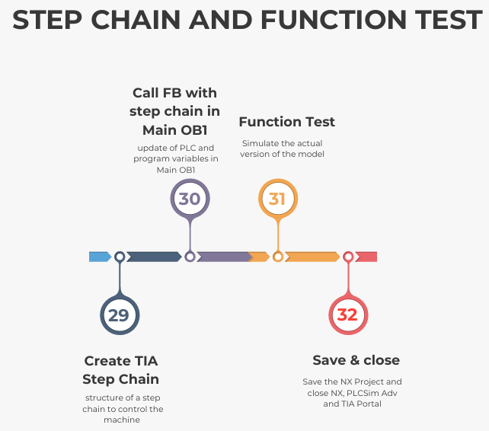
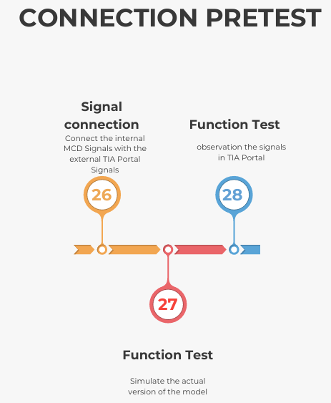

1
In this section we import an already existing simple CAD model to NX MCD and we will add physical behavior to the CAD model.
We use the concept of rigid bodies and collision bodies in order to simulate the effects of gravity, collision and friction. Joints between the bodies are used to make the bodies movable. Position controls are defined to limit and control the motion.

Open Siemens NX MCD, import the project, and save it

Video: 01Start-Import-Save

To use the software for modeling a digital twin, the NX Mechatronics Concept Designer (MCD) icon must be launched.
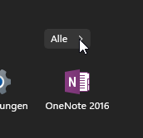 | 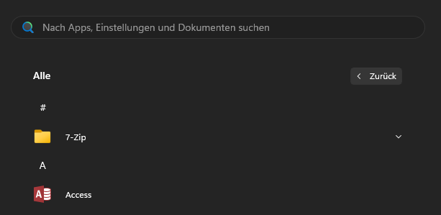 scroll here
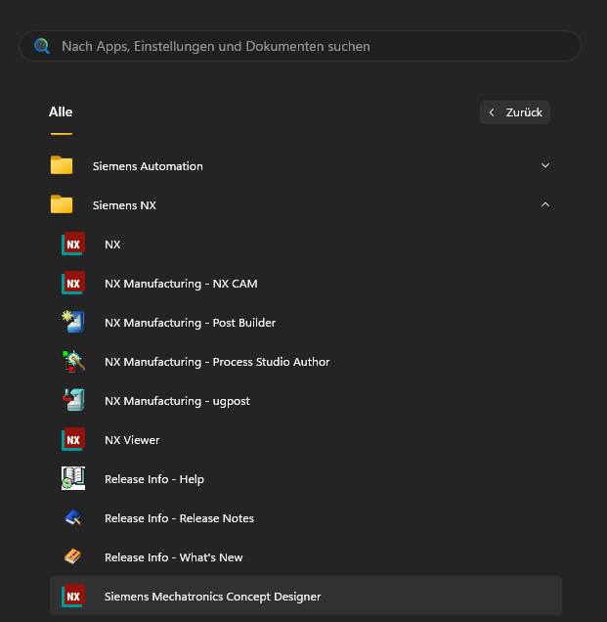
Once the NX interface has been opened, a pre-created STEP file can be imported using the OPEN icon. Before doing so, you must select "All Files" above the OK and Cancel buttons in order to view the STEP file.
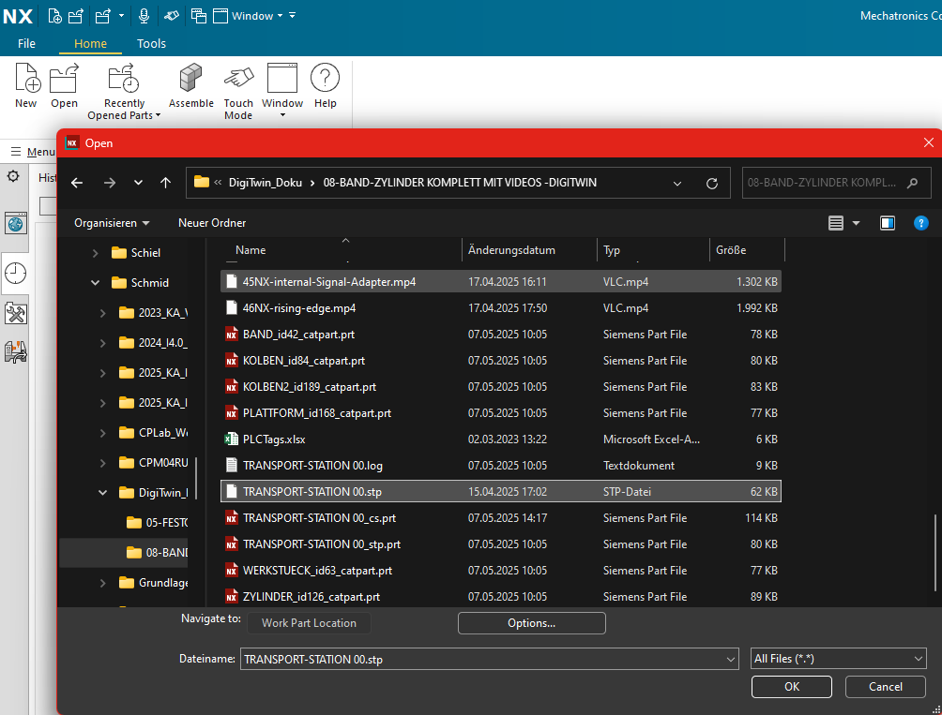
The STEP file TRANSPORT-STATION00.stp can then be imported into Siemens NX MCD and saved as a new project with the extension .prt (Part) using Save As.
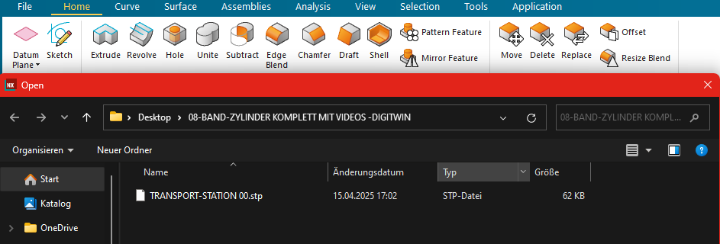

Save as with your own initials xy in the the file name TRANSPORT-STATION 00_xy.prt .
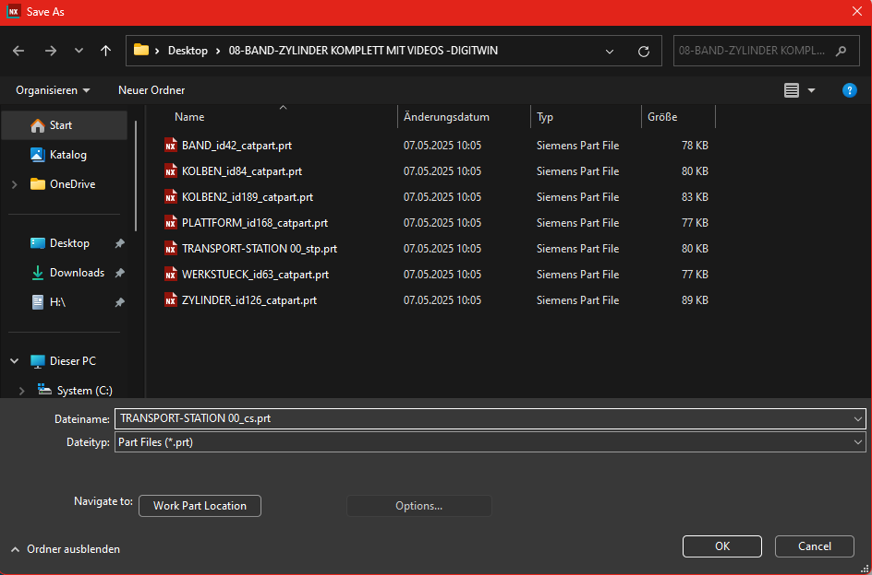

Choose first „Application” in the header and then the MCD tool can be started – press "More" icon in the header and choose Mechatronics Concept Designer
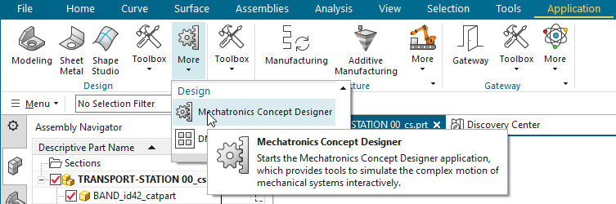
Through opening the MCD application automatically the Physics Navigator will be opened.

In this project, you can see after you select the “physics Navigator” that no definitions have been made yet. The Physics Navigator is still completely empty.

In this project, you can see that no definitions have been made yet. The Physics Navigator is still completely empty.
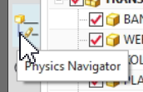

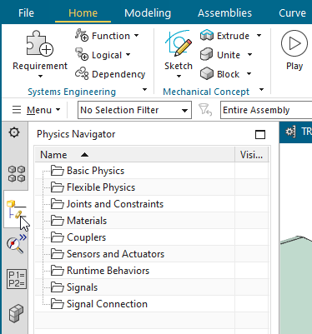

Definition of rigid bodies

Video: 02Rigid Bodies

It is suitable to apply the following rules.
Every component that should be movable in the later process must be defined as a rigid body in the NX model. A rigid body is defined as a Rigid Body
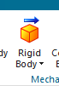.
To assign correctly the rigid bodies, you must first consider which components should be movable in your digital twin project.
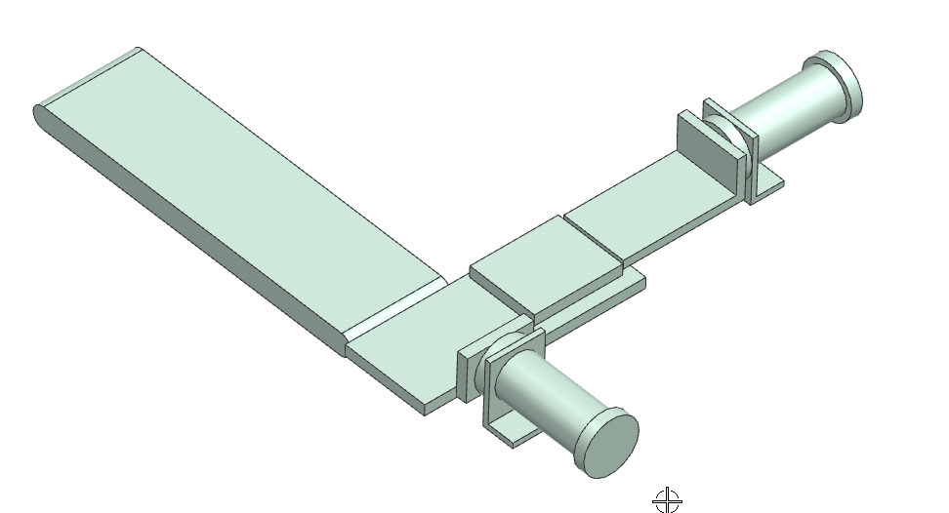

In this model, the two cylinder Pistons and the workpiece must be defined as rigid bodies, as these three components are supposed to be moveable in the simulation later on.

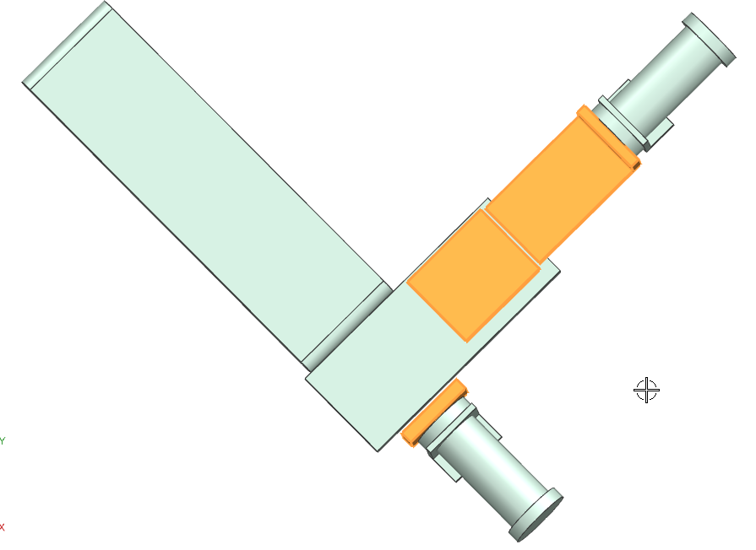
1
2
3

Definition of collision body

Video: 03Collision bodies
All components that are supposed to potenionally collide with each other in the subsequent process must be defined as collision bodies. Single Parts or surfaces are defined as Collision Body.
The collision body property allows bodies (such as cylinders) to move and push other bodies (such as the workpiece) away. In this example, cylinder 1 pushes the workpiece in front of the second cylinder, which then pushes the workpiece onto the conveyor belt.
Similarly, the transport surface must be defined as a collision body so that the workpiece on the conveyor belt can be transported after the cylinders have been moved.
Attention: collision bodies are continously surveyed during simulation, therefore they are consuming a lot of computer-power. They have to be applied in an economical way.
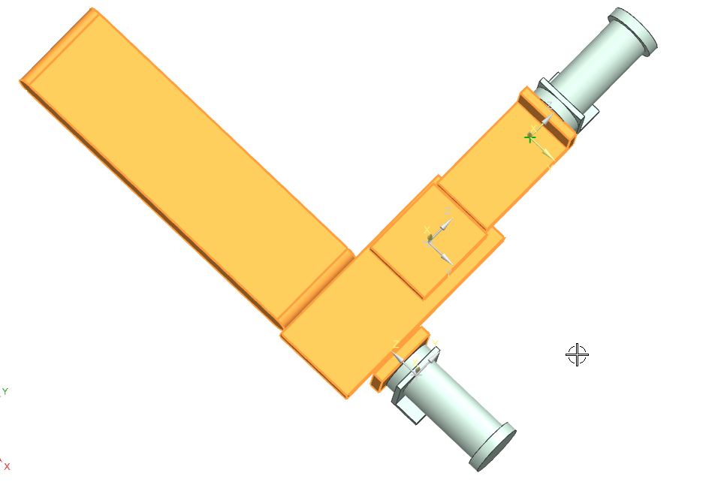
3
4
5
2
1

To define collision bodies, surfaces must be selected. In this example, the surface and the front of the ejector cylinder were selected.
The shape of the collision surface is defined as a "box." Due to the two surfaces selected so far and the "box" collision shape, the pink border is still tilted as a box.

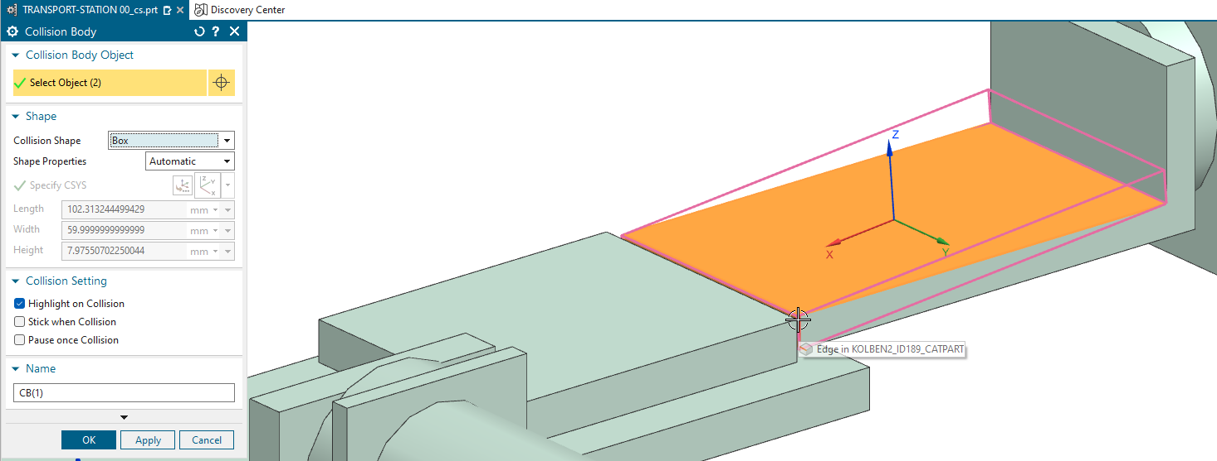

When a third and fourth surface are selected to define the collision body more precisely, the entire collision surface changes automatically and the pink border fits to the ejector cylinder. To do this, the side surfaces were also selected.

In most cases, it is sufficient to select three surfaces to define the collision body.
Please compare your result to the video.
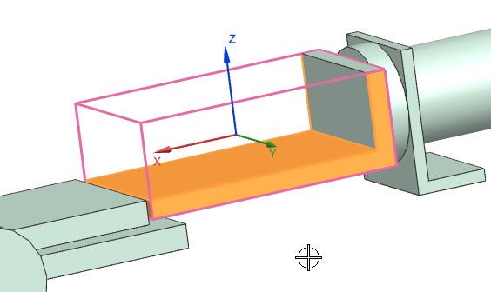
The collision surface created in the Physics Navigator, is stored in the project tree behind the rigid body see the “+” in front of RB1 (rigid body 1)
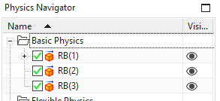
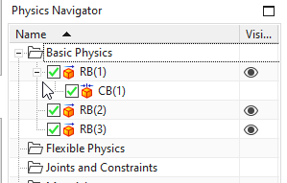
Once all collision bodies for the tasks have been defined, they should be displayed in the Physics Navigator as shown below.
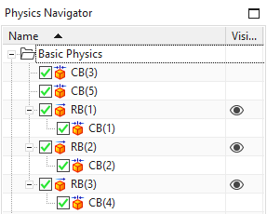
It is important to save the intermediate results regularly – only just in case of software troubleshooting
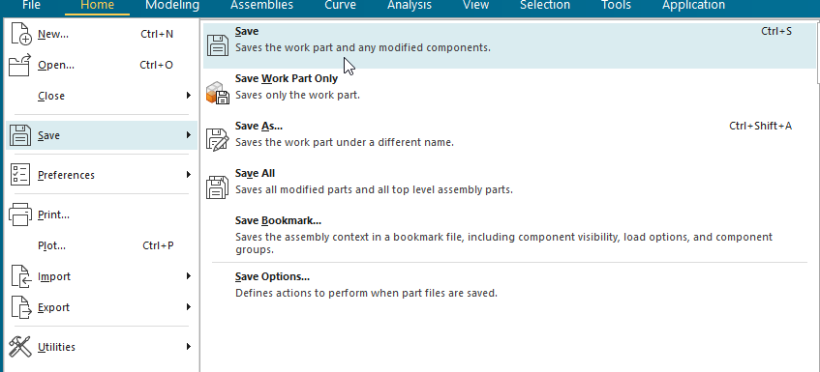

Testing and simulating the current status

Video: 04Test run
You can test the intermediate results at any time – the simulation is started using the Play button.
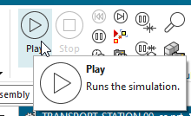
When the simulation is started, the two cylinder pistons simply fall down. The reason for this is that the cylinder pistons have not yet been attached to the cylinders via joints. These joints will be made in the next step.
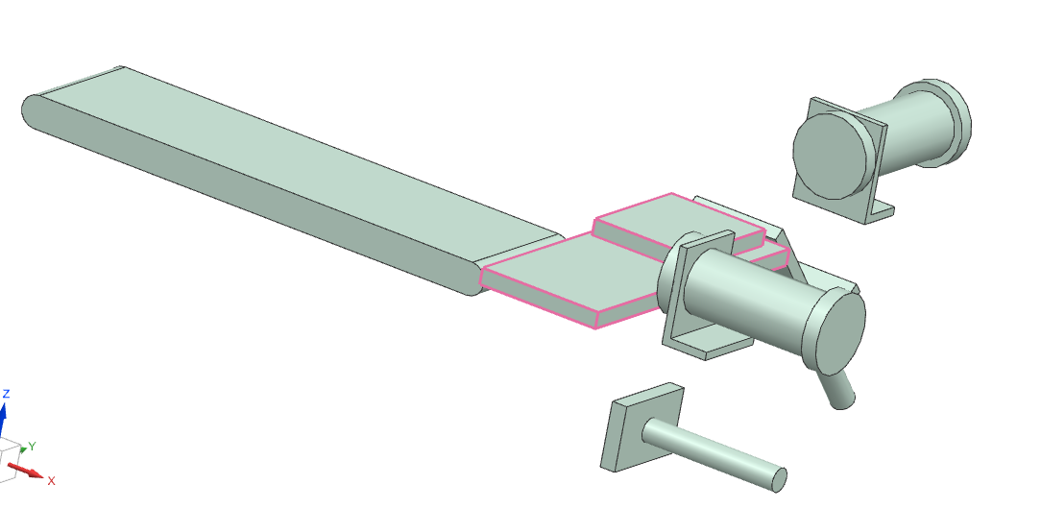
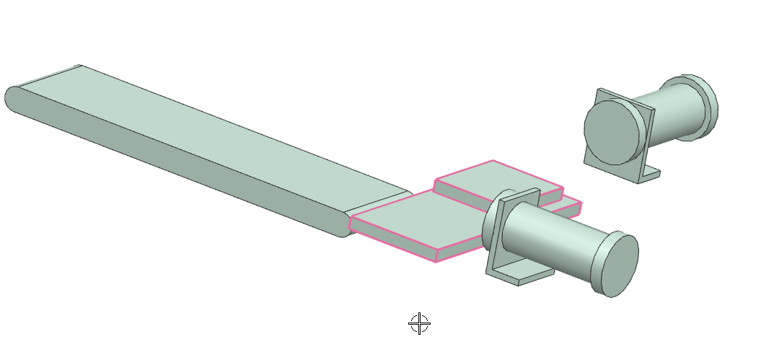 | After testing, stop the simulation again using the stop button.  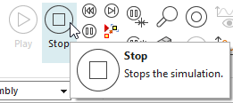

Creating connections – defining the sliding joints

Video: 05Joints

To make cylinder pistons 1 & 2 movable, there must be defined joints. This property makes the cylinder pistons movable and allows them to extend and retract in a targeted manner.
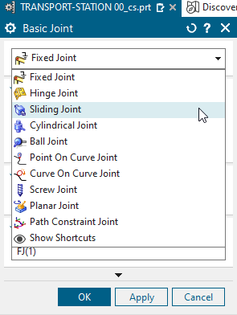
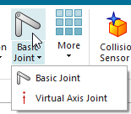

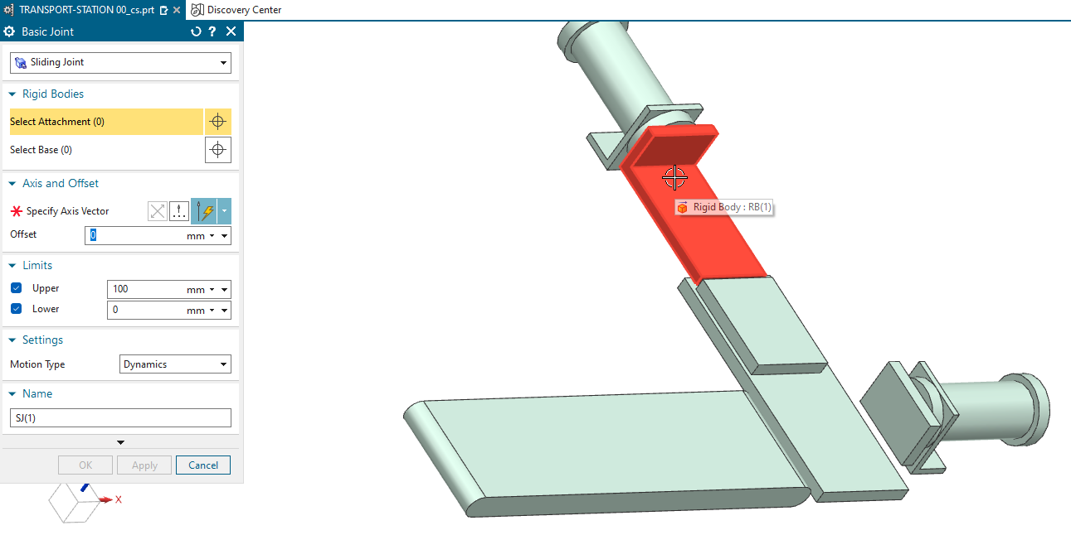

After selecting the cylinder/piston rod, the movement vector (the extension direction / specific axis vector) must be defined.
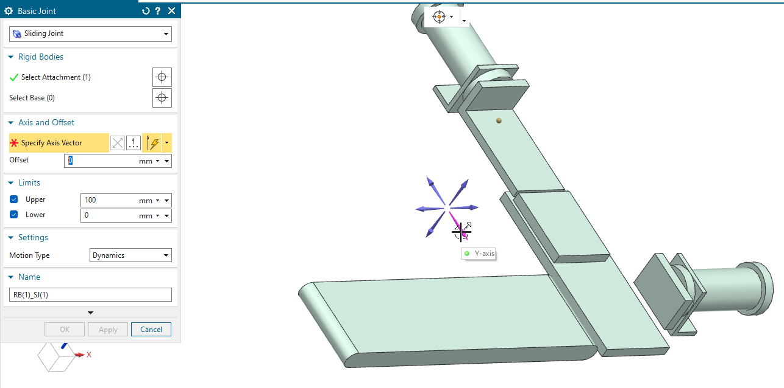
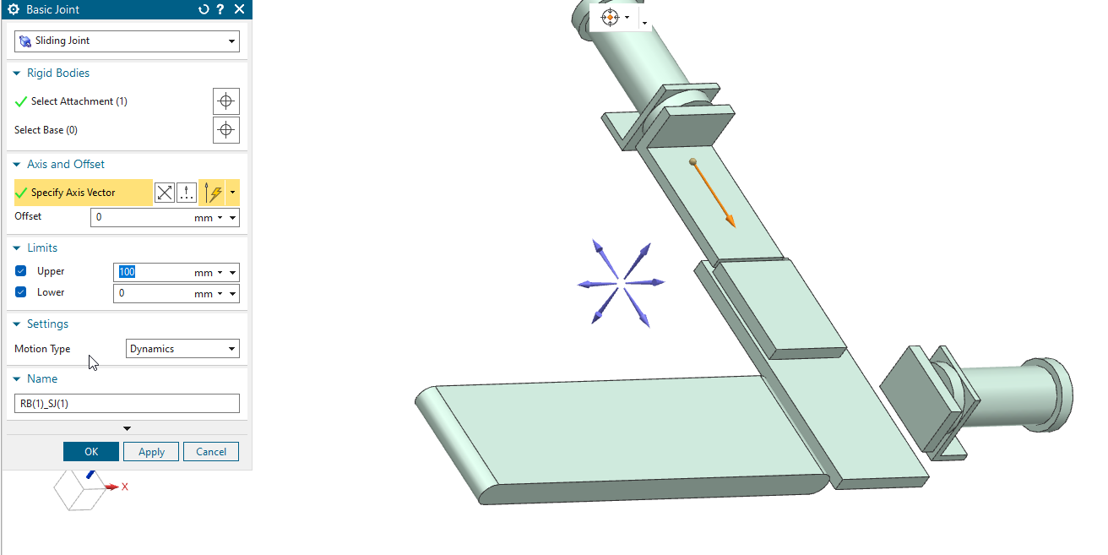

The extension length of the first cylinder should be 100 mm.
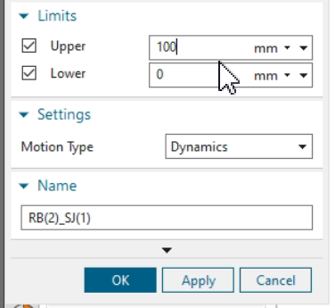

The procedure is then repeated for the second cylinder, also as a sliding joint. The procedure is analogous to that for the first cylinder.
First, select the body of the cylinder.
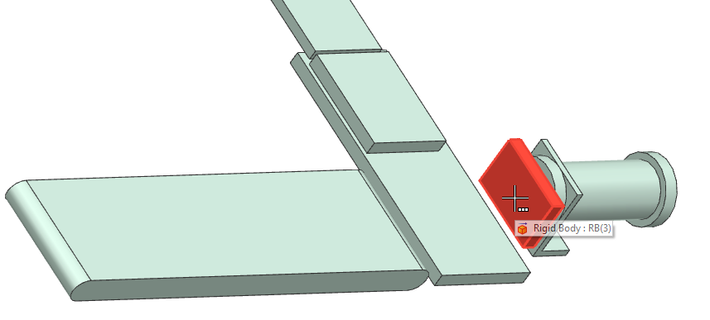

Then select the movement vector.
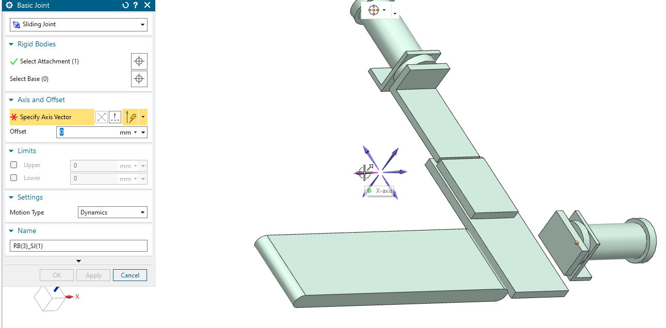

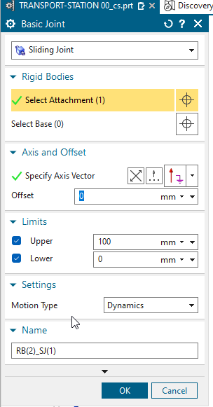
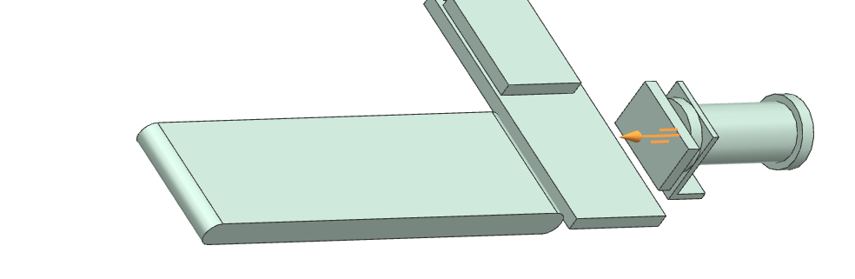
The maximum travel distance of the cylinder is defined in the Limits section – in our example, 100 mm.

Testing and simulating the current status

Video: 06Test joints

It is always advisable to test the intermediate status of the simulation project – therefore, the simulation must be started with the Run button.

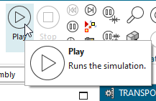

After starting the simulation (Run mode), the sliding joints can be moved using the mouse with a pressed mouse button.
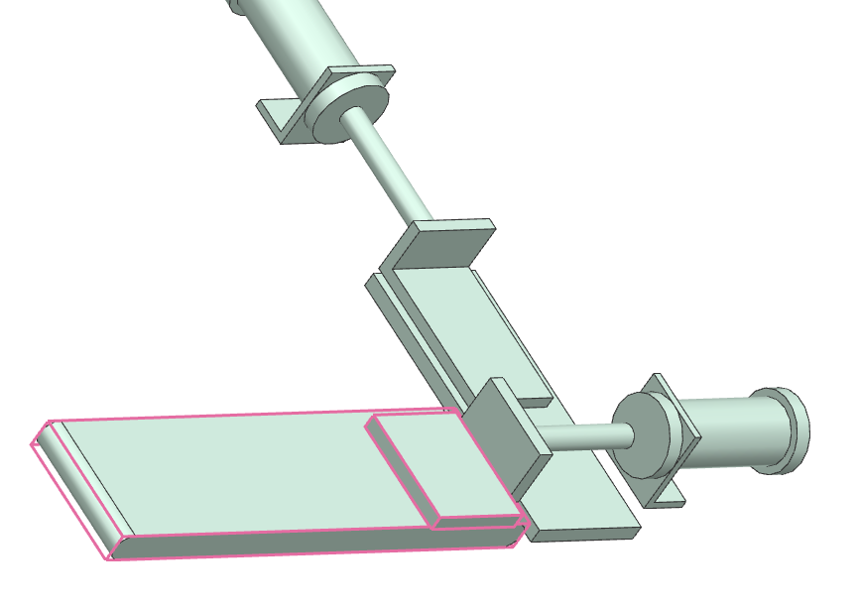
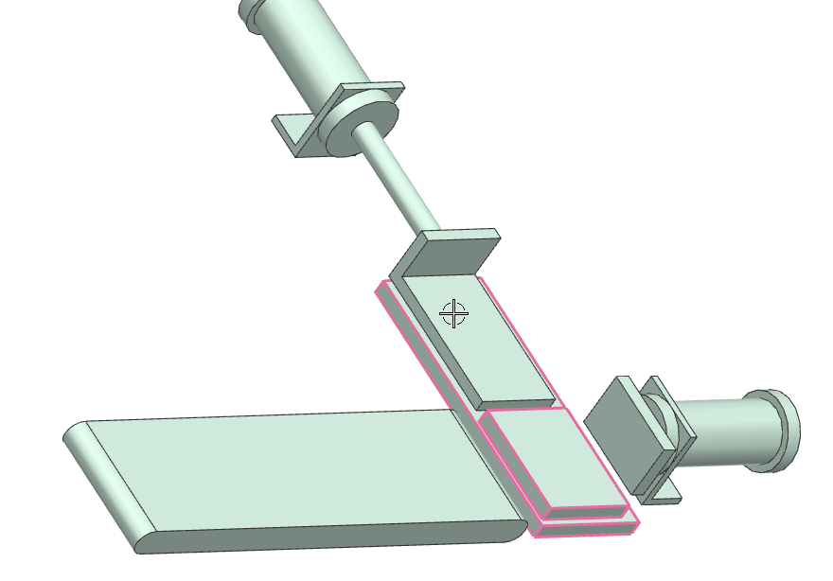

Implementation of position monitoring on actuators

Video: 07Pos-Controls

These steps give the cylinders their range of motion. In the case of the cylinder, this is extension and retraction using solenoid valves MB1 and MB2 for cylinder 1.
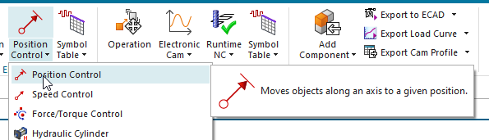
Solenoid valve 1 MB1
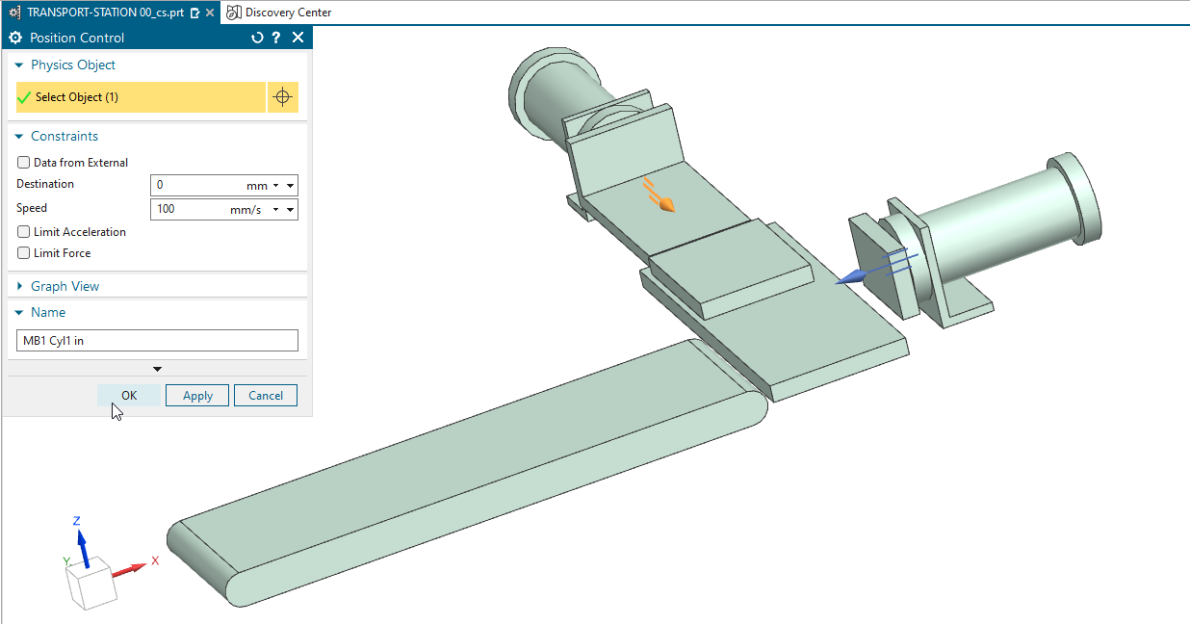

Solenoid valve 2 MB2
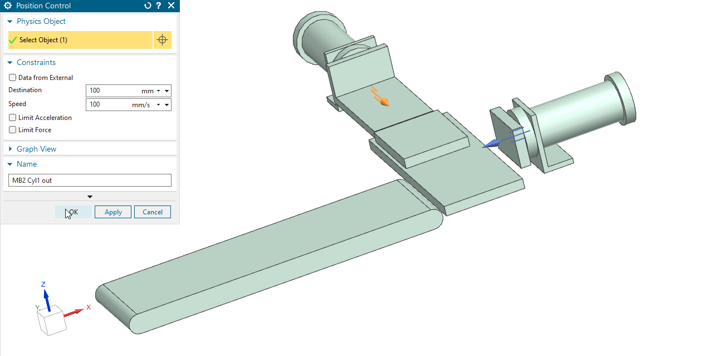

Solenoid valve 3 MB3
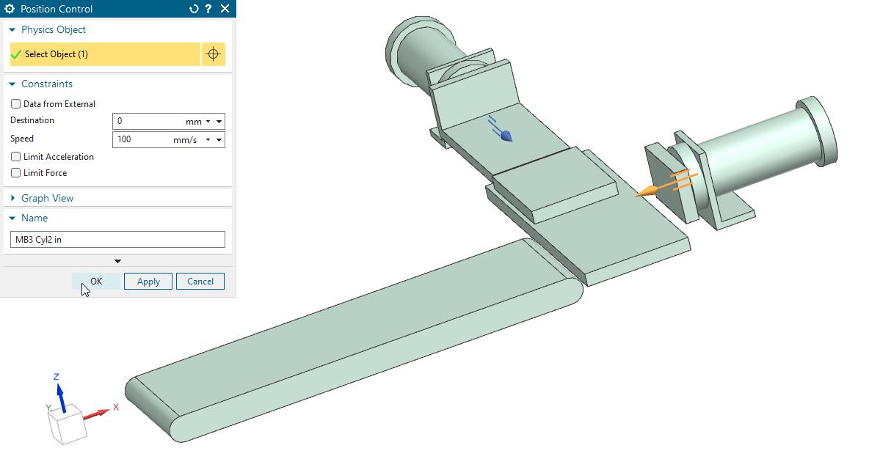

Solenoid valve 4 MB4
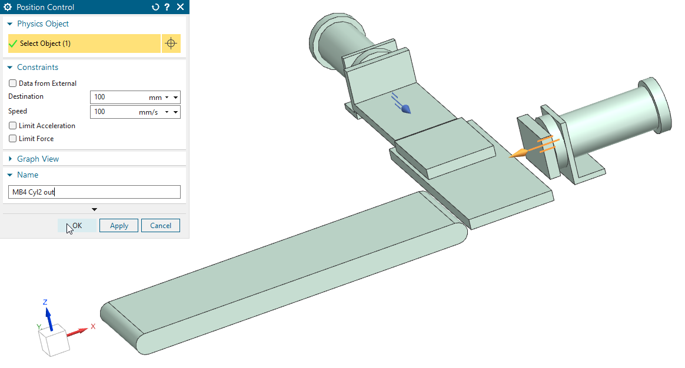

Integration of transport surfaces

Video: 08Conv-Belt
In order to transport the workpiece to the next station on a conveyor belt after it has been handled by the two cylinders, this transport surface must be defined.
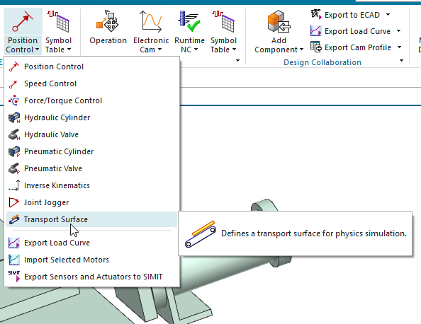

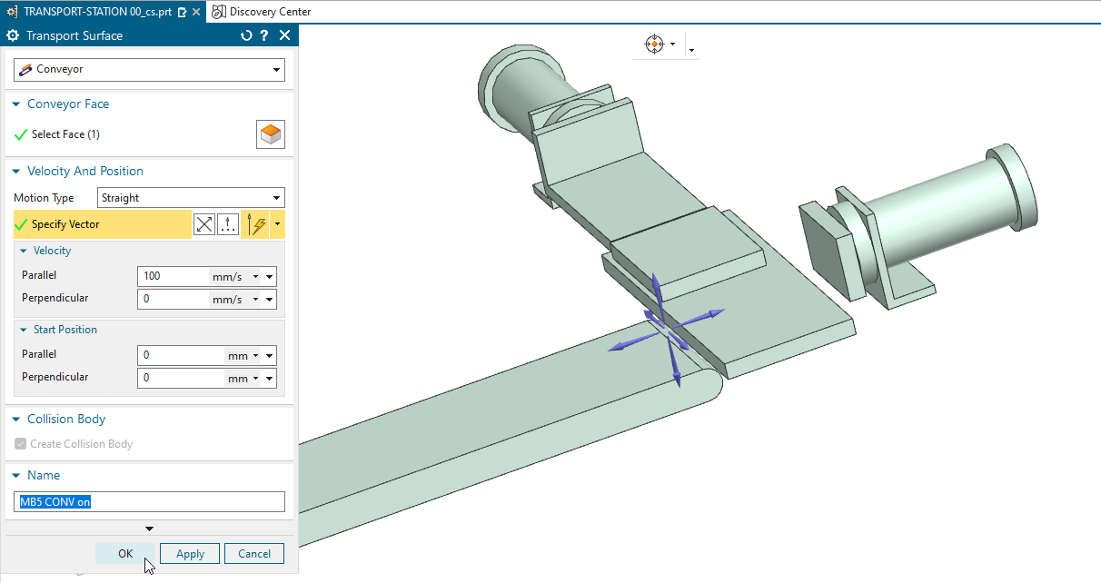

Interim test of actuators (cylinders and conveyor belt)

Video: 09Test run

Once all actuators have been integrated, they can be tested manually.
To do this, first deactivate all actuators (remove check marks) and start simulation mode using the Run button.
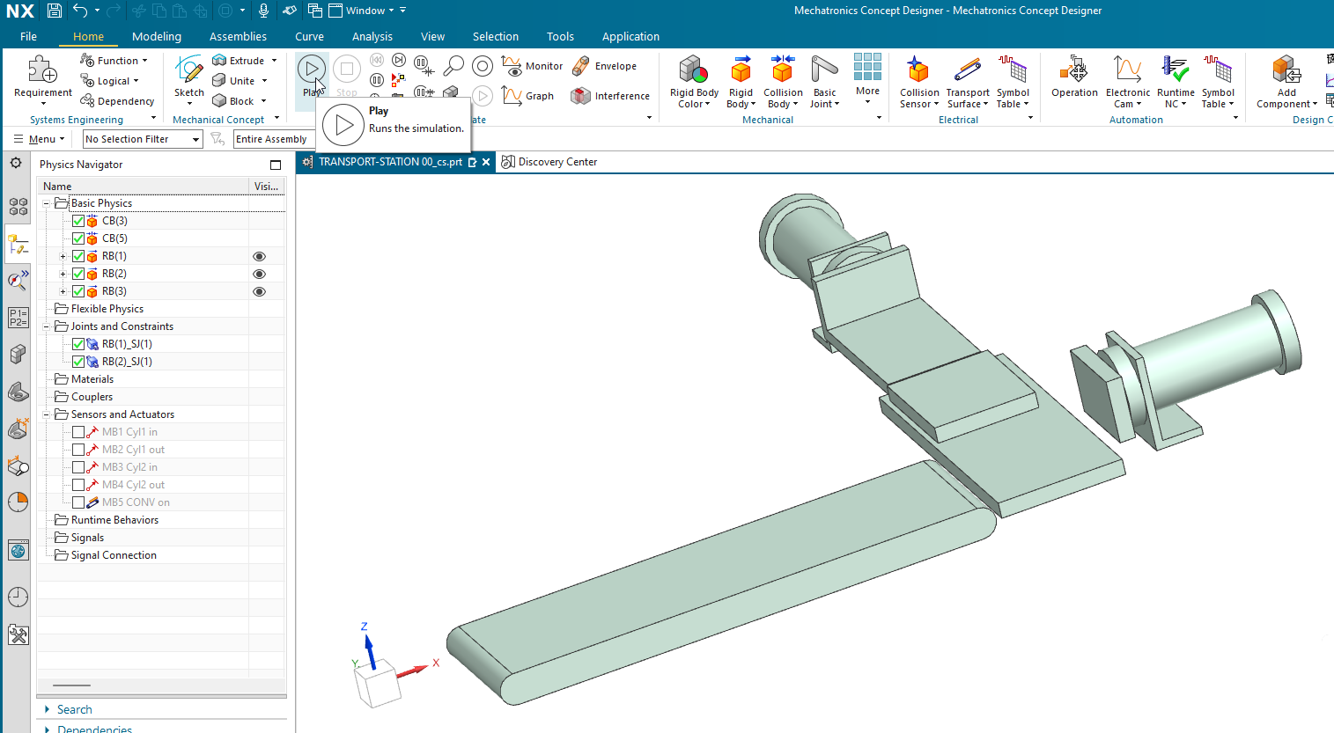
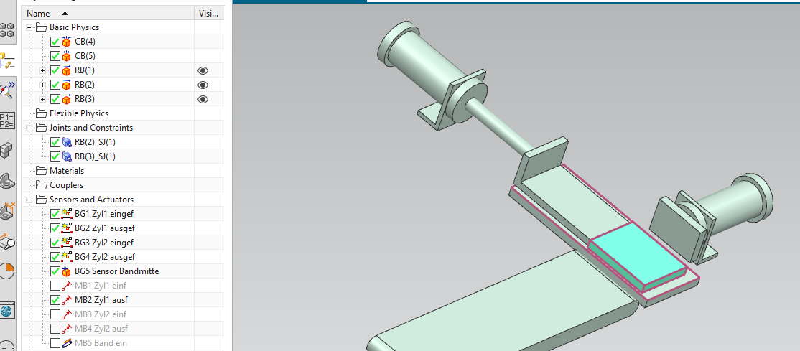

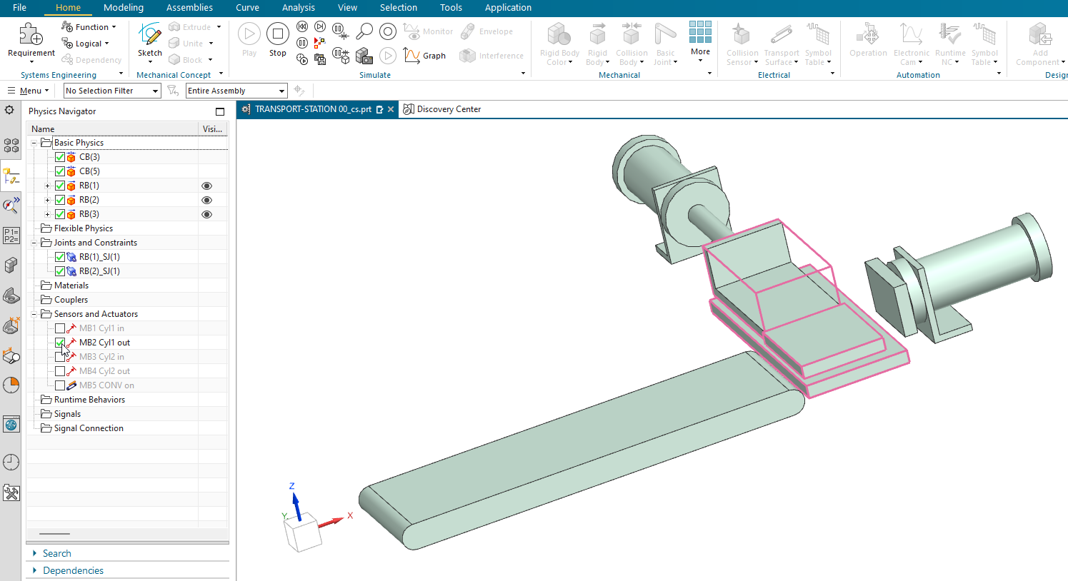
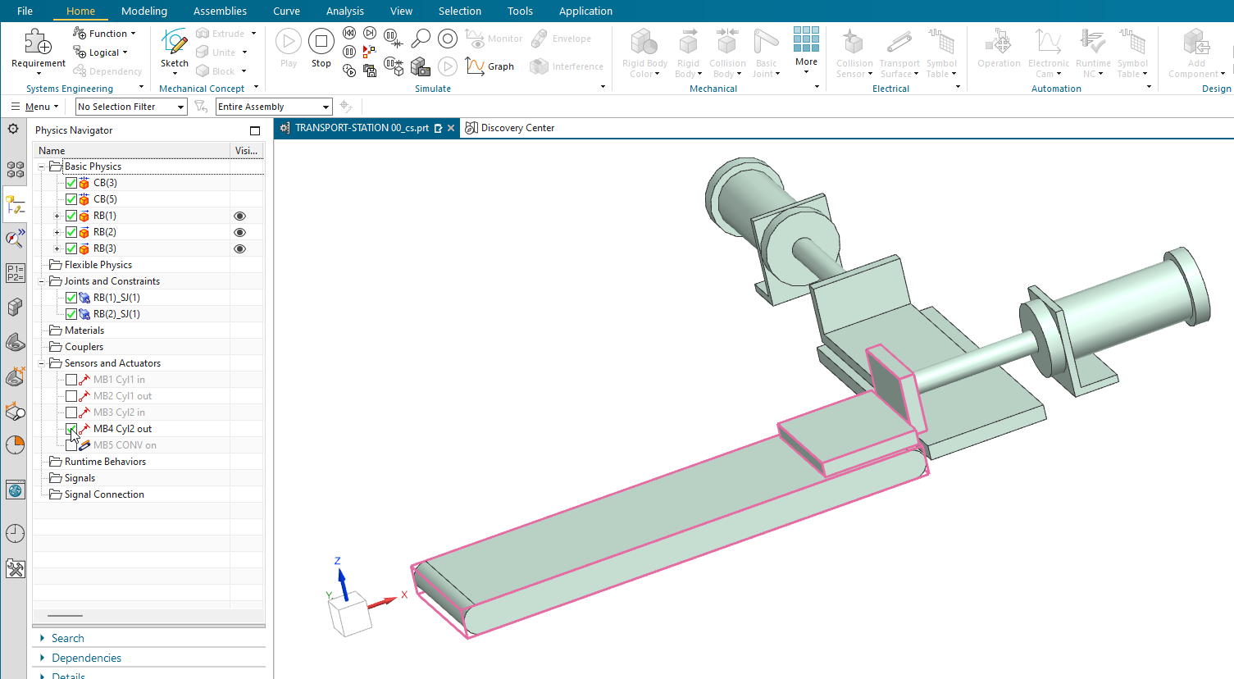

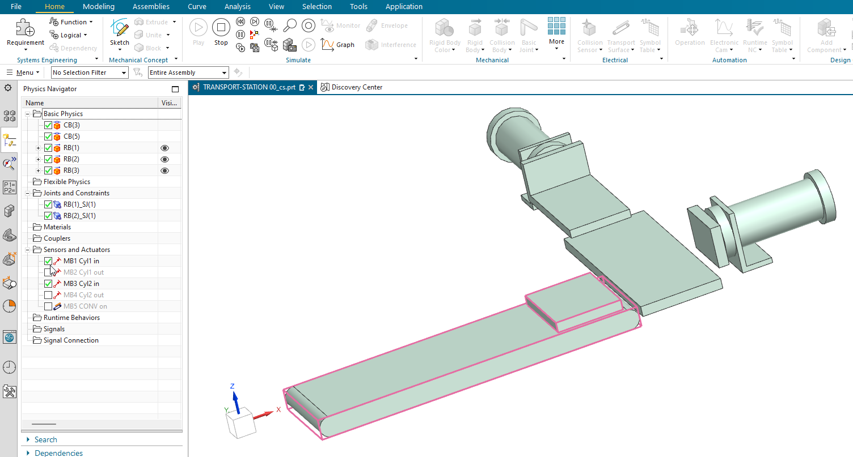

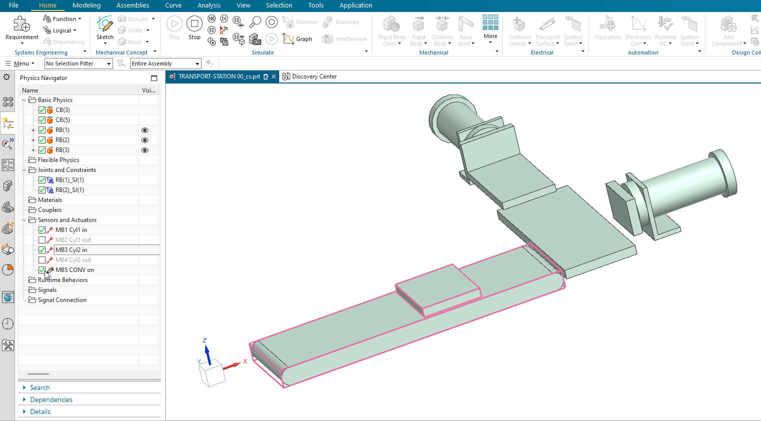

Integration of end position monitoring on actuators

Video: 10Limit switches

In the next step, limit position monitoring (sensor limit switches) are to be integrated for the two cylinders.
This limit position monitoring is defined with the reference codes: BG1 - BG2 - BG3 - BG4
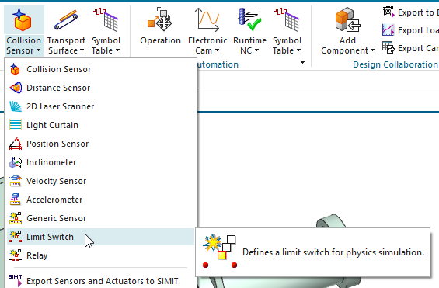
End position monitoring for cylinder 1 retracted BG1
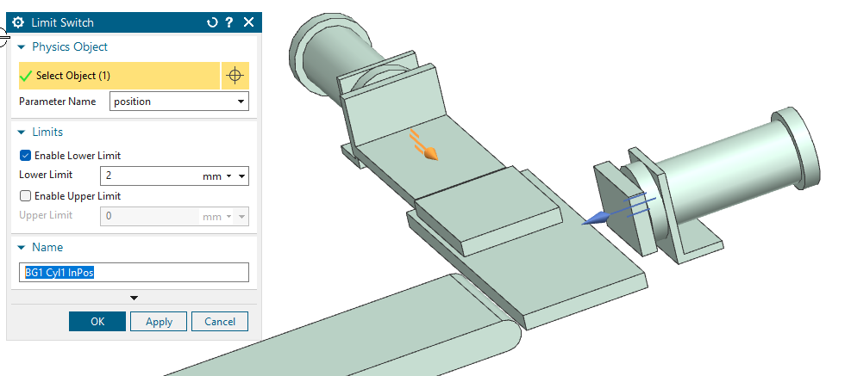
End position monitoring for cylinder 1 extended BG2
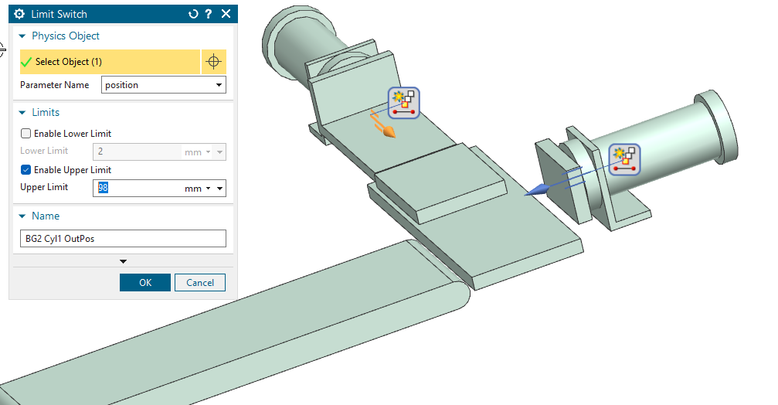

End position monitoring for cylinder 2 retracted BG3
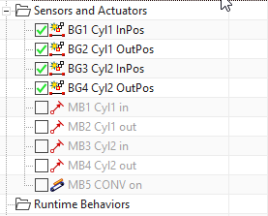
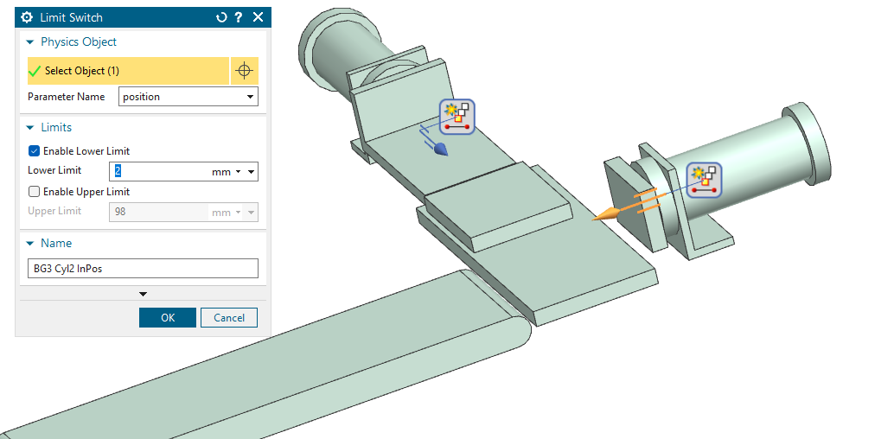

End position monitoring for cylinder 4 retracted BG4
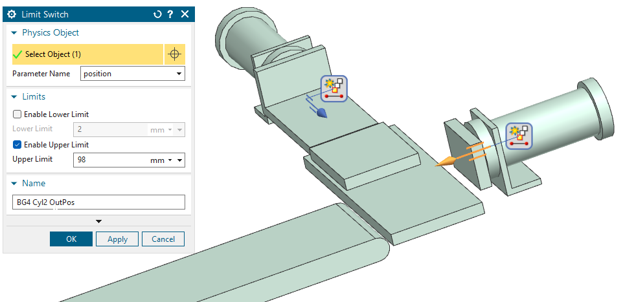

Function test of end position monitoring on actuators

Video: 11Test-Limitsw

The Runtime Inspector, a monitoring function, can be used to monitor signals in NX.
If the limit position sensors BG1-BG4 are selected with the SHIFT and mouse click and added to the Inspector (right click and choose Add to Inspector), they can be monitored in simulation mode in the view (next image).
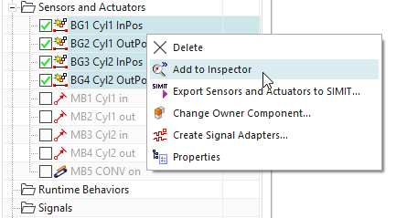 | 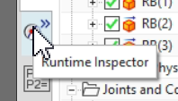

Open the Inspector Window and adjust the size of the presentation.
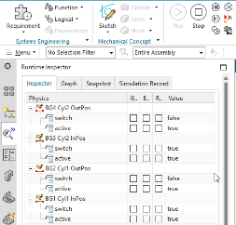
Situation 1: Cylinder 1 is retracted

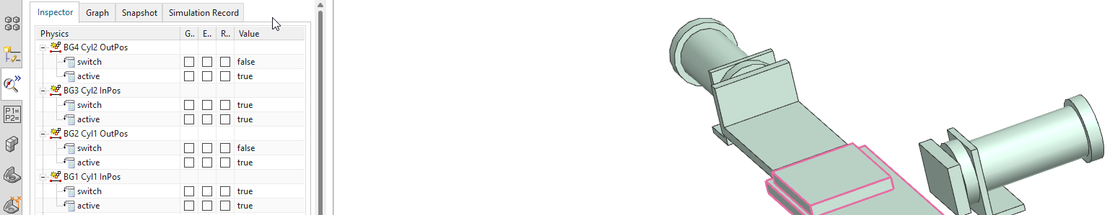

Situation 2: Cylinder 1 is extended
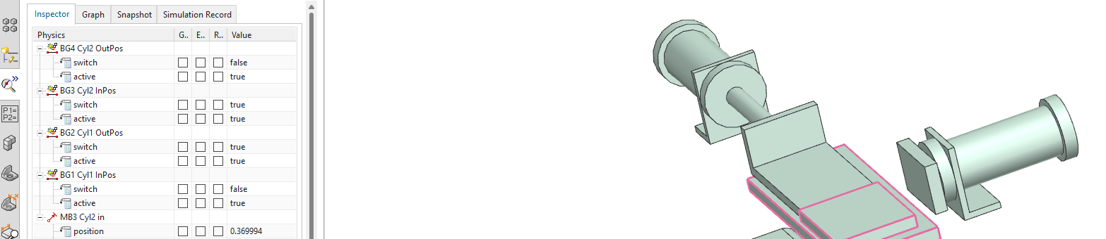

Integration of buttons in the NX model

Video: 12Start button

A start button is required to control the model during simulation with an external PLC because a initial signal is needed to start a step chain or something else.
To do this, you must integrate a geometry into the model that performs the required functionality.
A cylinder that is subsequently integrated into the model and also has the properties of a runtime button takes on the task of initiating the sequence control.
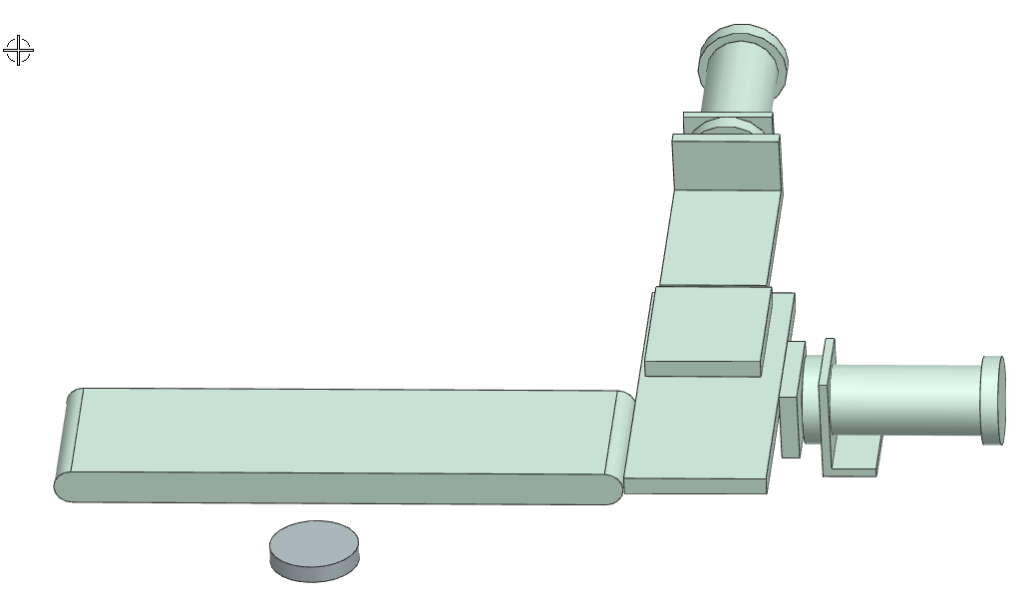
Menu for integrating a cylindrical body into the NX model.  In this case, a cylindrical button is anchored in the model. | 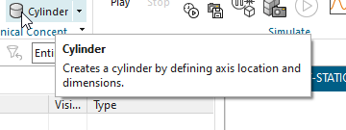
The size, orientation, and position of the button can be varied in the dialog box.
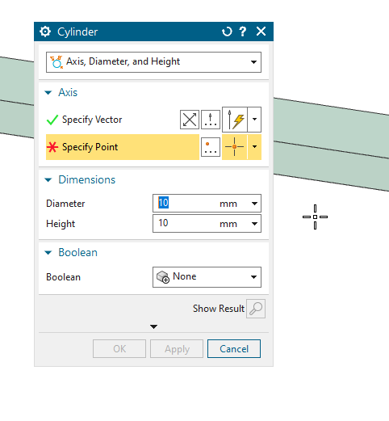
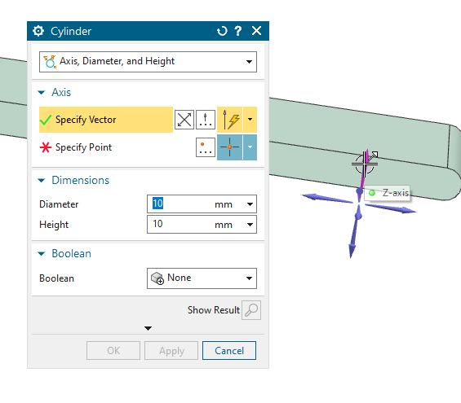
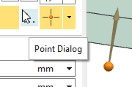

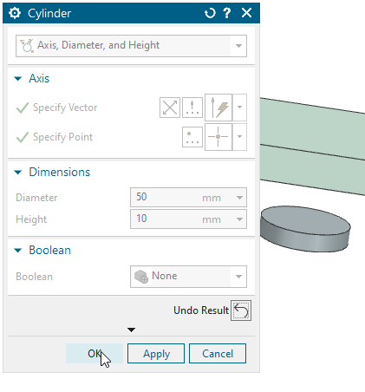
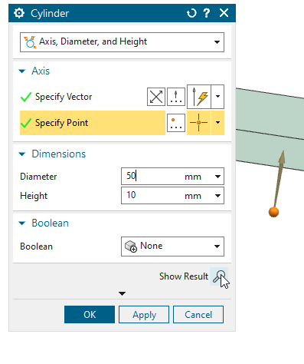
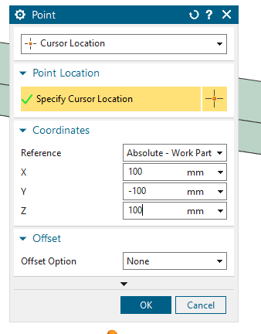
The behavior of the button is then defined. In this case, the button is to transmit a trigger signal to the control system.
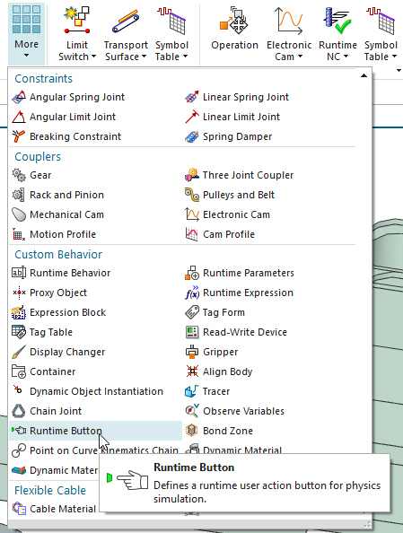 | 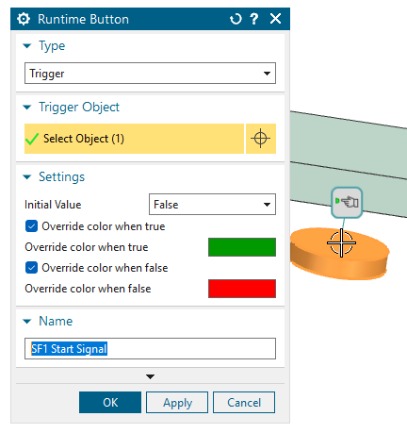

Disclaimer
Funded by the European Union. Views and opinions expressed are however those of the author(s) only and do not necessarily reflect those of the European Union or the European Education and Culture Executive Agency (EACEA). Neither the European Union nor EACEA can be held responsible for them.

