

Course materials

Digital twin documentation
Key concept for product development

Status: Jun 2026

Author: Dr. K. Krettenauer
C. Schmid
B. Geibel

Table of Contents
0 Model analysis with task 4
13 Importing a symbol table for variable names 7
14 Selection and definition of parameters for the inputs in NX 10
15 Selection and definition of parameters for outputs in NX 12
16 Assignment of signals in the signal adapter 14
17 Connecting parameters and signals in the signal adapter 17
18 Connecting input parameters and signals in the signal adapter 20
19 Simulation release in the TIA Portal 23
20 Create PLC hardware and integrate PLC variables 28
21 Creating a function block in the TIA Portal 31
22 Program creation in the function block 33
23 Call the FB in Main OB1 and save the program 35
24 Creating a new simulation instance in PLCSim Advanced 37
25 Load TIA program in PLC Sim 39
26 Creating signal connections in MCD 42
27 Temporary storage and testing of the software status in NX 47
28 Testing the software status in the TIA Portal 48
29 Creation of a step chain program 50
30 Control of the outputs of the step chain program 51
31 Testing the software version with NX 56
32 Save status and close entire project 57
33 Reopen the SimCaer virtual PLC 59
34 Reopen the NX simulation project 59
35 Integration of a stop button in the NX simulation 59
36 Integration of a text description in NX 60
37 Embed the function runtime button for the stop signal 60
38 Adjustment for the stop signal in the signal adapter 60
39 Adjustment for the stop signal in the signal connection 61
40 Adjustments in the TIA Program for the stop signal 61
41 Environment test of the stop button in the NX simulation 62
42 Integration of two new collision sensors in the NX simulation 63
43 Adjustment for the collision sensors in the signal adapter 63
44 Integration of a source and sink for the production parts 63
45 Adjustment for workpiece source in the signal adapter 64
46 Adjustment for a rising edge in the signal adapter 64

Note: The numbering of the captions starts with 13 because of the continuing of the process chain. In Module 3 you already made the steps 1 to 12.

Model analysis with task

The NX model used for this exercise contains two pneumatic cylinders and a conveyor belt.
The task of the system is to first push a workpiece (rectangular body) laying on a plate with two pneumatic cylinders and then transport the workpiece away using the conveyor belt.

An additional start button can be used to initiate a sequence of steps for the sequence control. The double-acting pneumatic cylinders are controlled via solenoid valves and their position is monitored by limit switches.
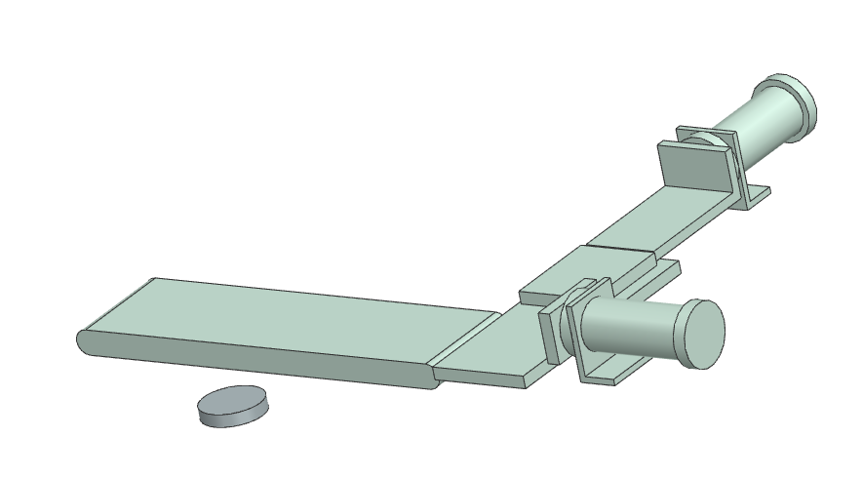
Start button
Cylinder 1
Cylinder 2
Conveyor belt
Workpiece

In the following work process, the already existing CAD model (assembly in STEP file format ) is imported to Siemens NX MCD .
Parts of the model will be made „physically“ movable so that the model can be linked to a control system (in our case PLC SIM advanced from SIEMENS) and the associated programming environment (in our case TIA-Portal from SIEMENS).
The whole work process is devided into five sections.
1
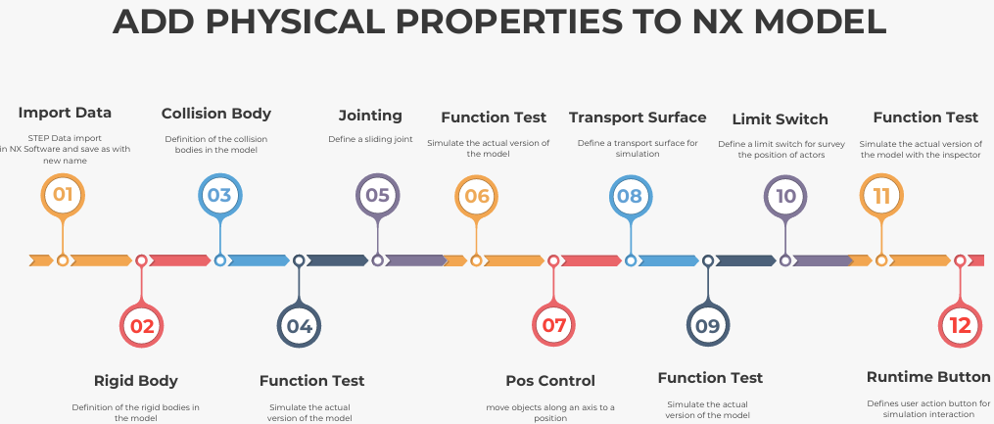
2
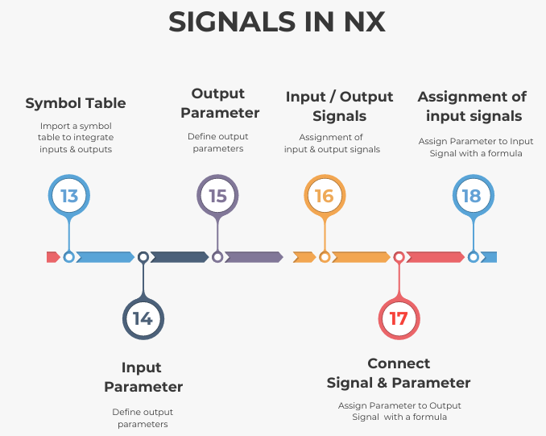
3
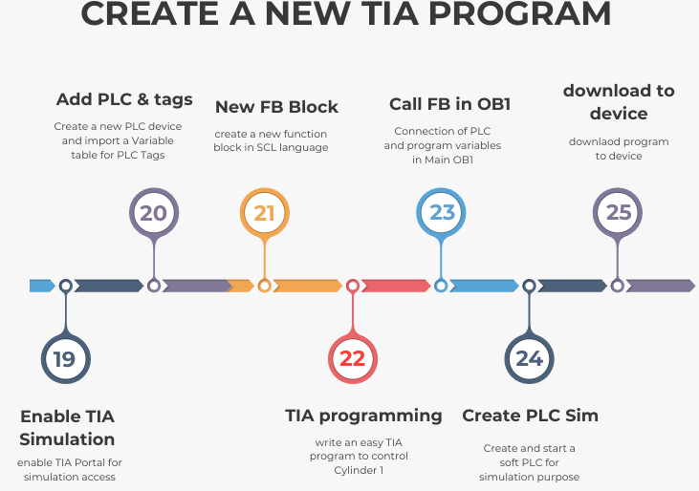

4
5
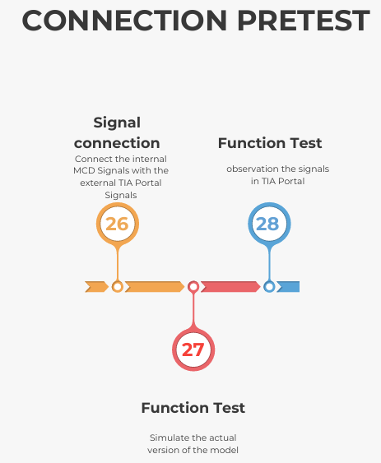
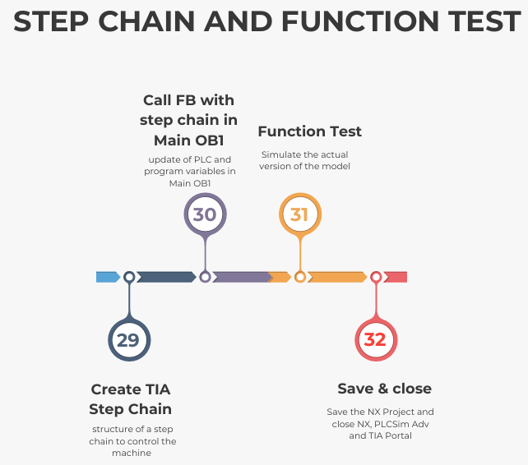

Part 2  2 | A crucial part of working with NX MCD is the creation of signals and their assignment.  Movements of actuators and sensor signals are assigned to parameters in order to be connected to PLC signals later on.  This mapping takes place in the Signal Adapter, which forms the core of communication between the digital model and the PLC Software.

Importing a symbol table for variable names

Video: 13Import Symbols

The next step is to import a symbol table containing the variable names of the PLC variables from the TIA Portal project in order to facilitate the signal mapping with the PLC program later on.
If, as in our example, the naming structure is identical, the variable assignment can be done automatically for simulation purposes.
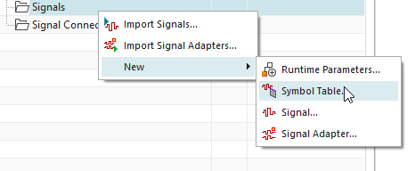
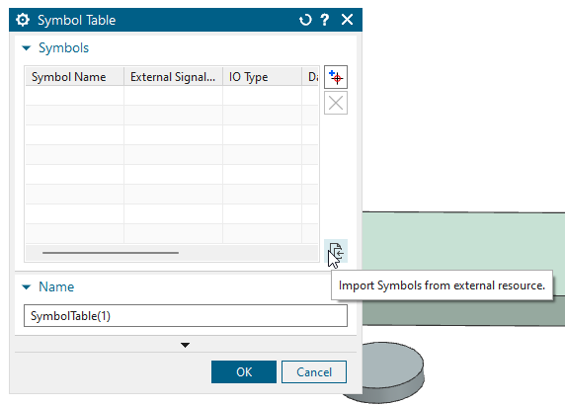
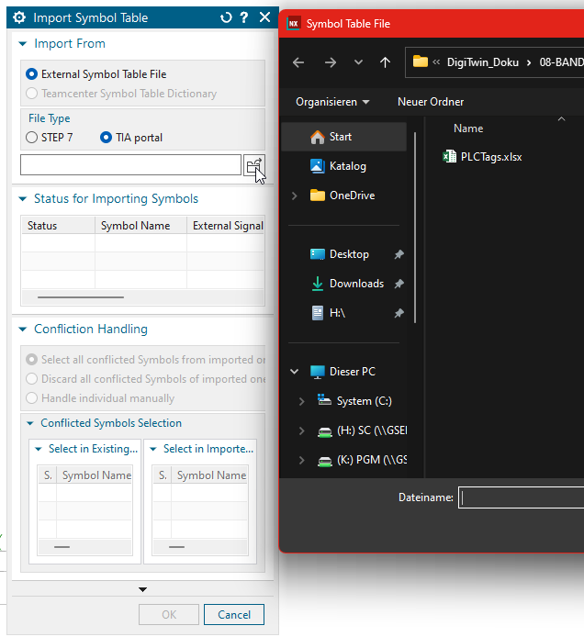
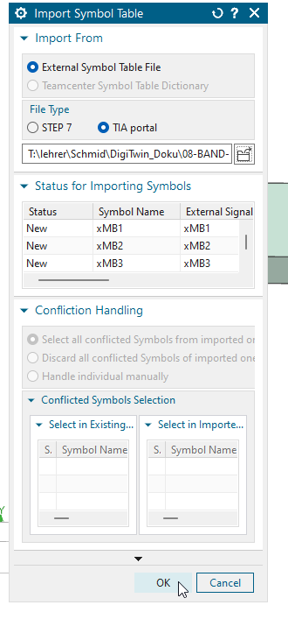 | The symbol table is then generated automatically.  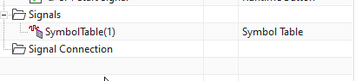
In the symbol table in the NX model, you can see that the assignment for MB1 (solenoid valve), for example, is declared as an input, and for sensors such as BG1 (end position monitoring), it is declared as an output.
The reason for this is that the variables are viewed from the perspective of the NX model, and in this case, a sensor is an output because it delivers a signal to the controller, and the solenoid valve is an input because the signal comes into the NX model as an input signal from the PLC.
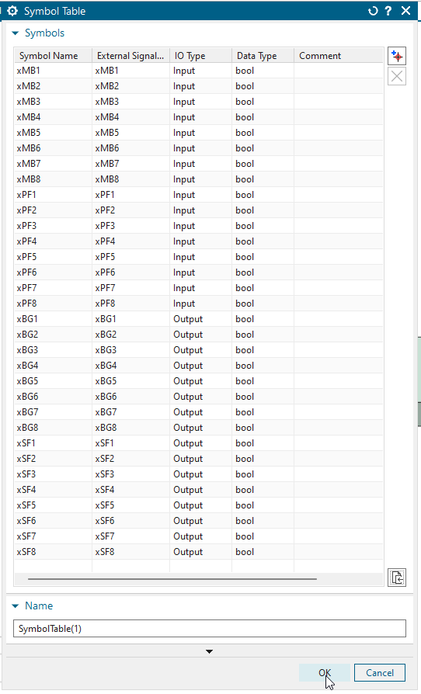

Selection and definition of parameters for the inputs in NX

Video: 14Signals-Ad-Inputs

In this step, parameters for individual sensors are defined specifically according to the respective application.
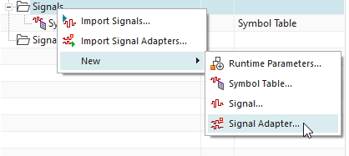

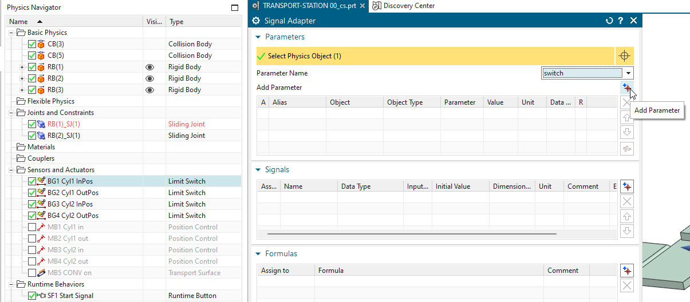

The limit position sensors are defined with the parameter type "switch" and the start button with the parameter type "triggered."
Please check the overall view about the sensor situation.
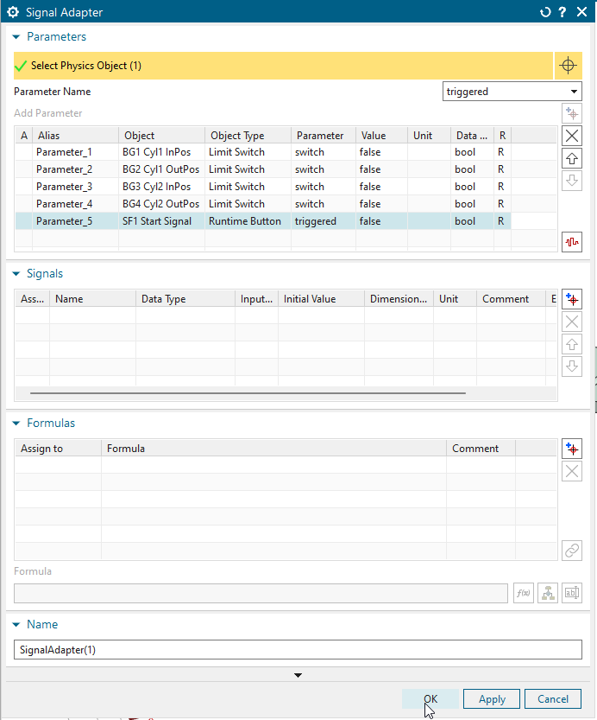

Selection and definition of parameters for outputs in NX

Video: 15Signals-Ad-Outputs

In this step, parameters for individual actuators are defined specifically for the respective application.

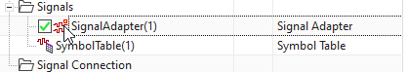

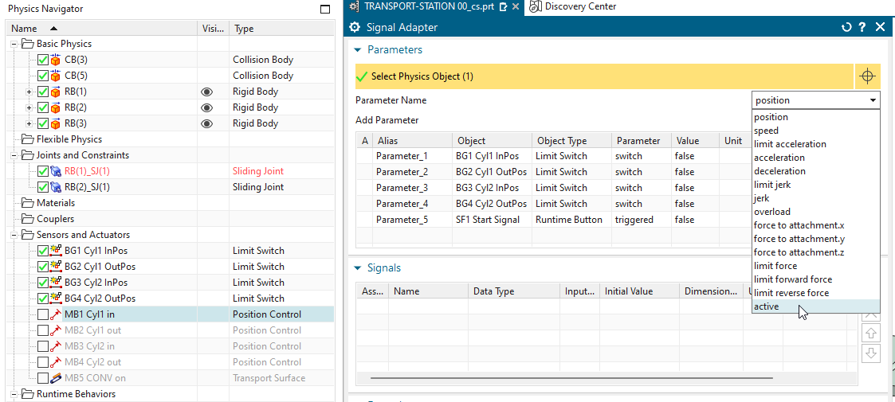

When defining the parameters, a definition with the parameter type "active" is used.
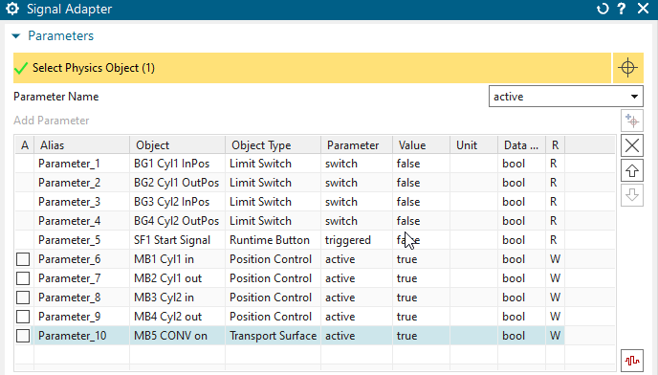

Assignment of signals in the signal adapter

Video: 16Add_Signals

All input and output signals are then created in the signal adapter.
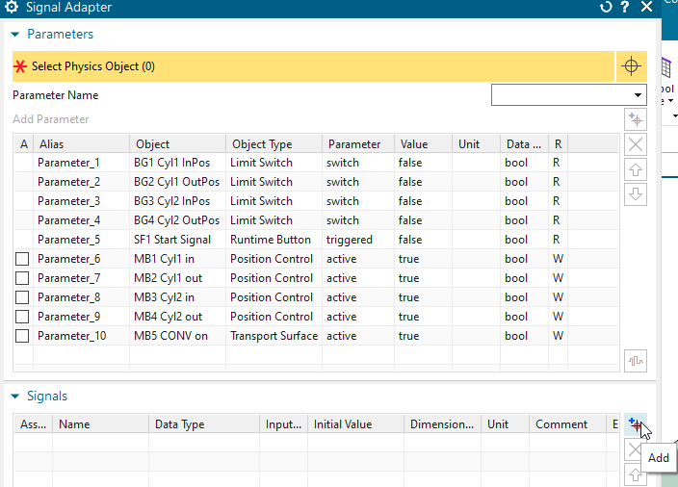

The assignment of whether it is an INPUT or OUTPUT is made from the perspective of the NX model. This means that an actuator is defined as an INPUT and a sensor as an OUTPUT.
After the import of the sensors (Outputs for the simulation) the topic must be change for the solenoid valves to an Input.

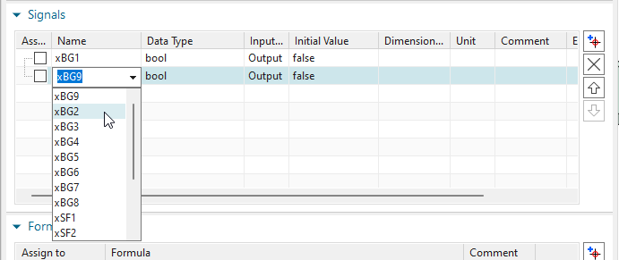

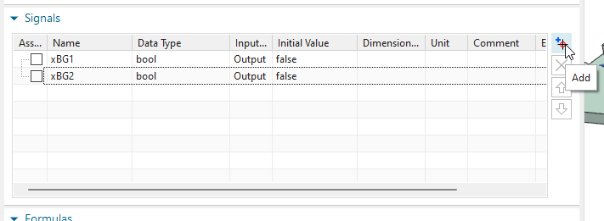

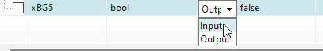

The assignment of whether it is an INPUT or OUTPUT is made from the perspective of the NX model. This means that an actuator is defined as an INPUT and a sensor as an OUTPUT.
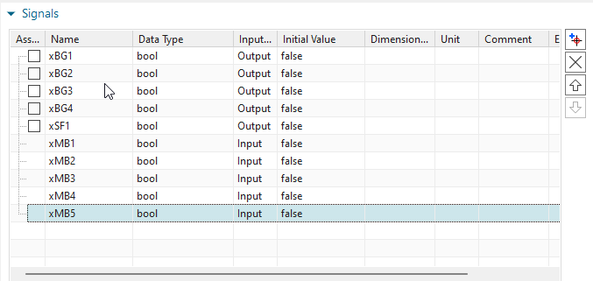

Connecting parameters and signals in the signal adapter

Video: 17Connect_MB

In this step, the individual signals are manually merged with the respective matching parameter.
In the first step, the output parameters are checked and then assigned to the corresponding signal via the Formulas area.
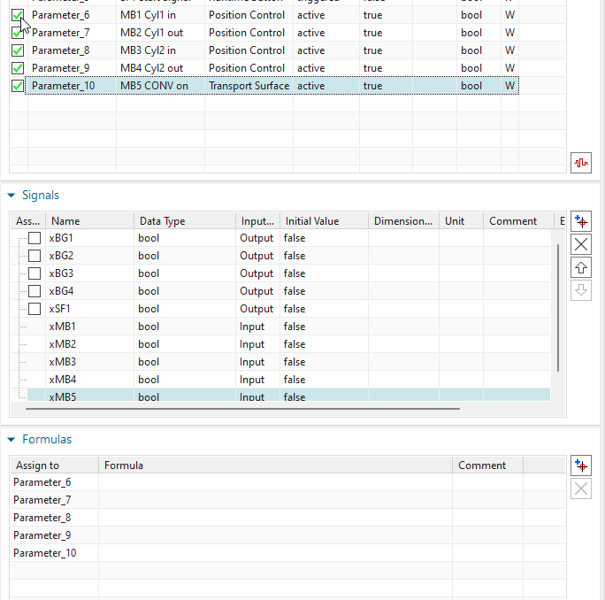
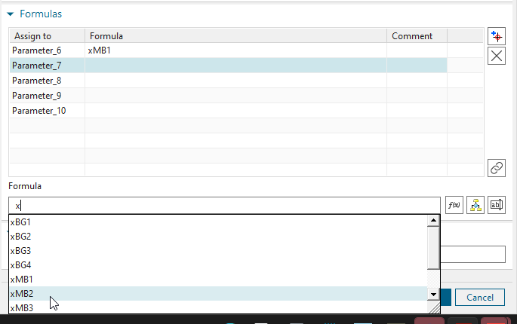

Please press enter to complete and confirm the formula input!!!

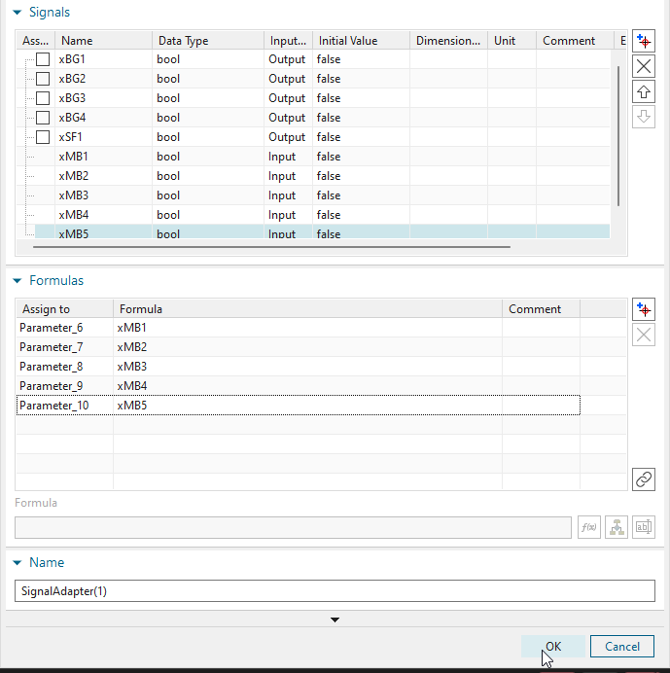

Connecting input parameters and signals in the signal adapter

Video: 17Connect_BG

In this step, the individual signals are manually merged with the respective matching parameters.
In this step, the input signals are checked and then assigned to the corresponding parameter via the Formulas area.
This corresponds to a reverse assignment as in the previous point.
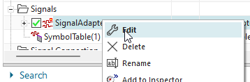
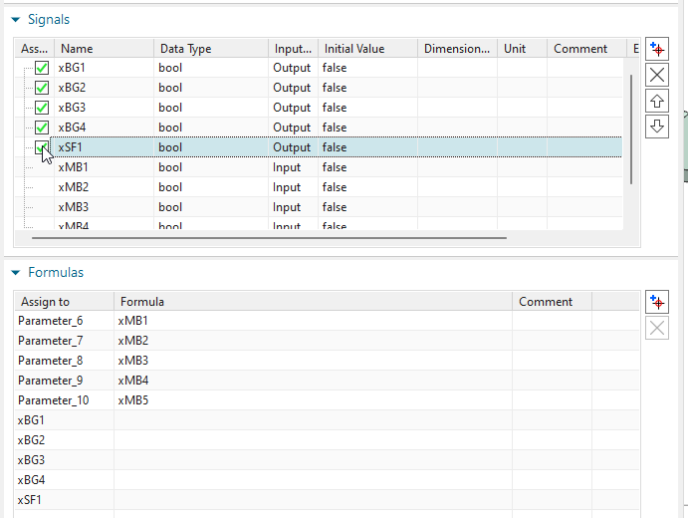

Please press enter to complete and confirm the formula output!!!
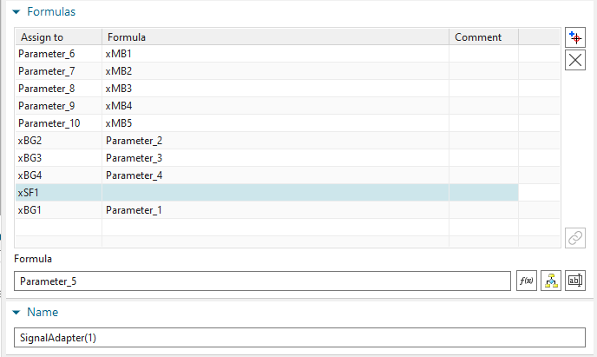

Part 3
3

In this section we create the TIA Portal Project for the programming part of the digital twin.
We start with a new function block (FB) and add the code to control one cylinder. PLC Sim advanced takes the role of a soft PLC and we download our program to an instance of it.

Simulation release in the TIA Portal

Video: 19TIA_new_enable_Simulation

In order to work with a simulation in the TIA Portal, this simulation option must first be activated in an empty project.
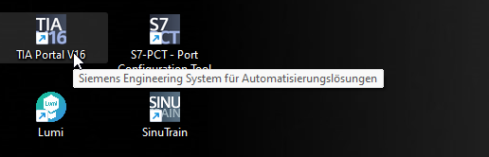
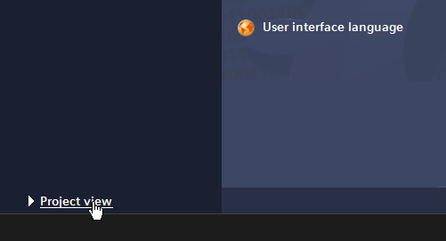

Create empty/new project
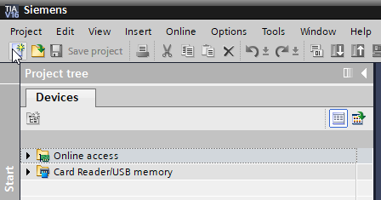

Set the path to the C:// drive (this is different in the video, please use your desktop)
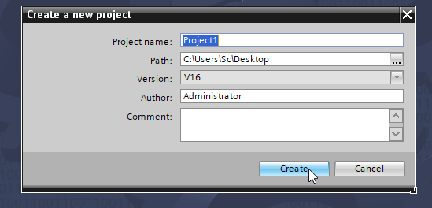
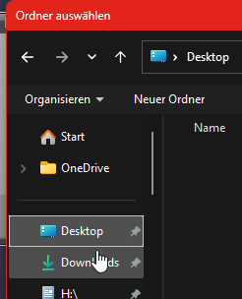
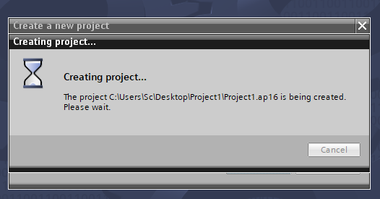

Right-click on the project and then select Properties
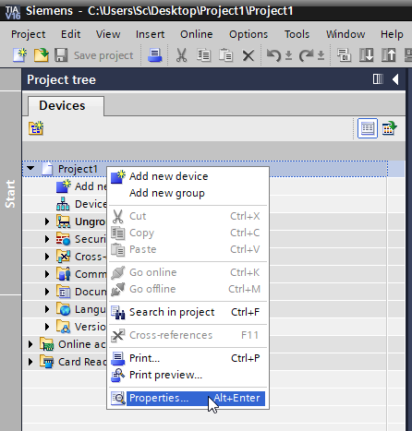

Simulation must be activated
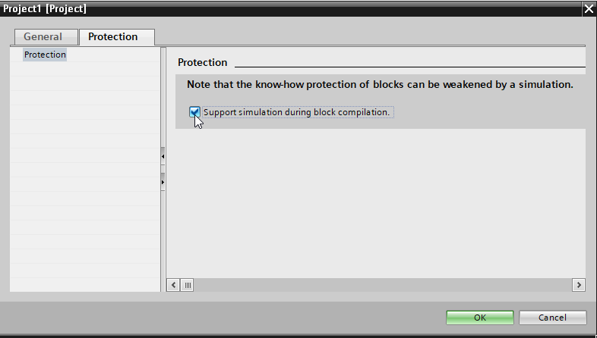

Create PLC hardware and integrate PLC variables

Video: 20TIA_new_PLC_Import_Variables

A hardware configuration for a PLC must be defined.
In this case, a 1500 PLC is used, as this corresponds to the reality on site.
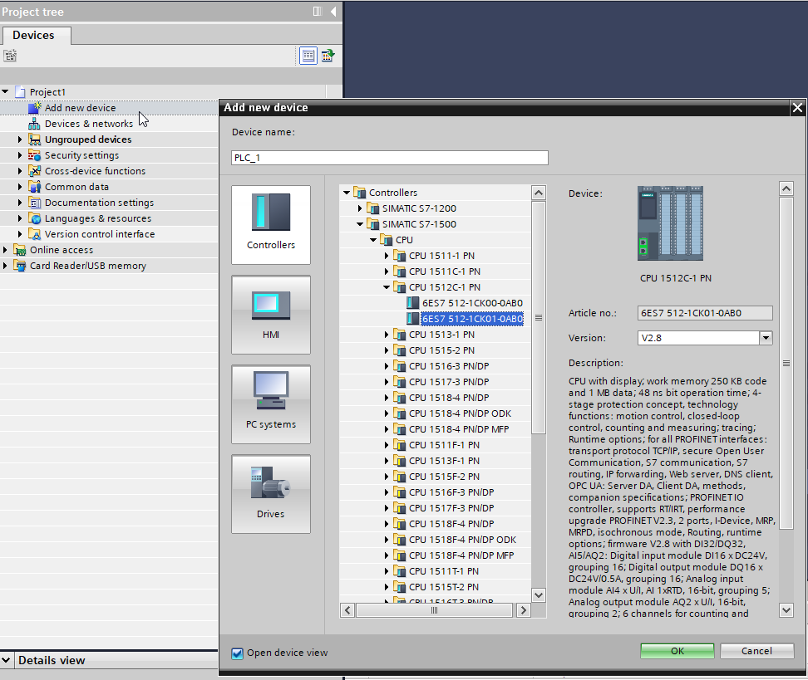

Once the PLC has been configured, the PLC variables (PLC tags) are imported using an Excel file. The file is located in the folder – Appendix PLC_Tags.xlsx.
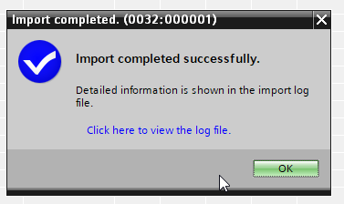
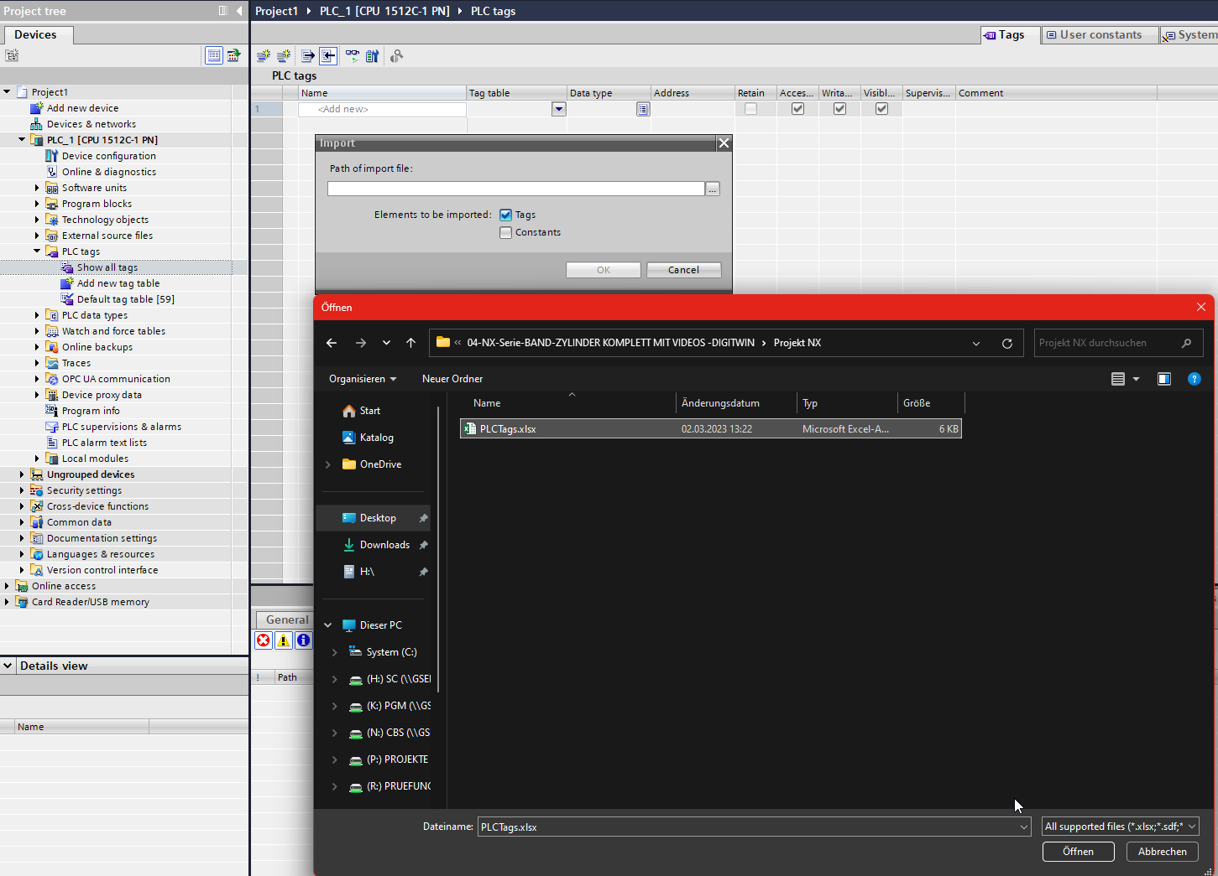

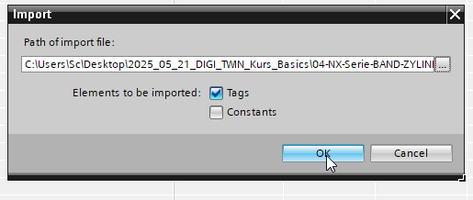
Overview of the imported PLC variables.
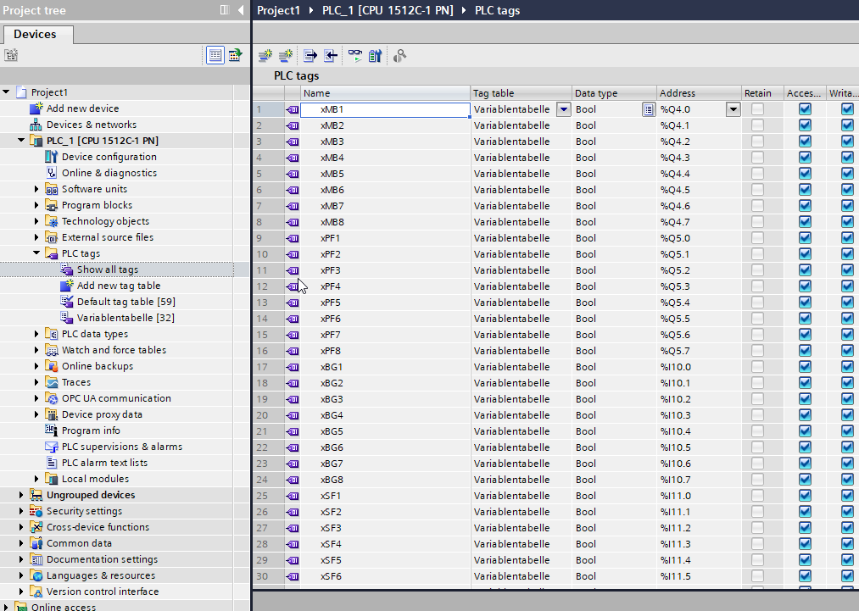

Creating a function block in the TIA Portal

Video: 21TIA_New_FB
Changing the programming language in the MAIN OB1 block
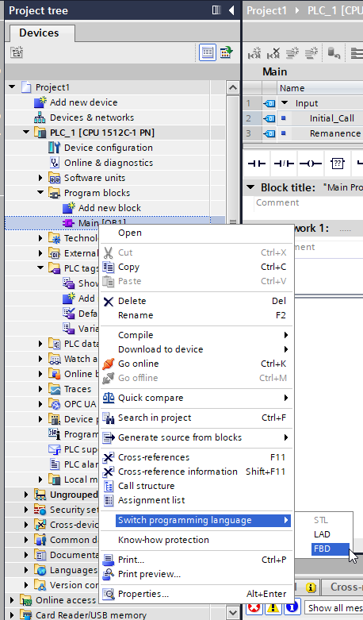
A new function block is then created using the SCL programming language.
Please select function block!

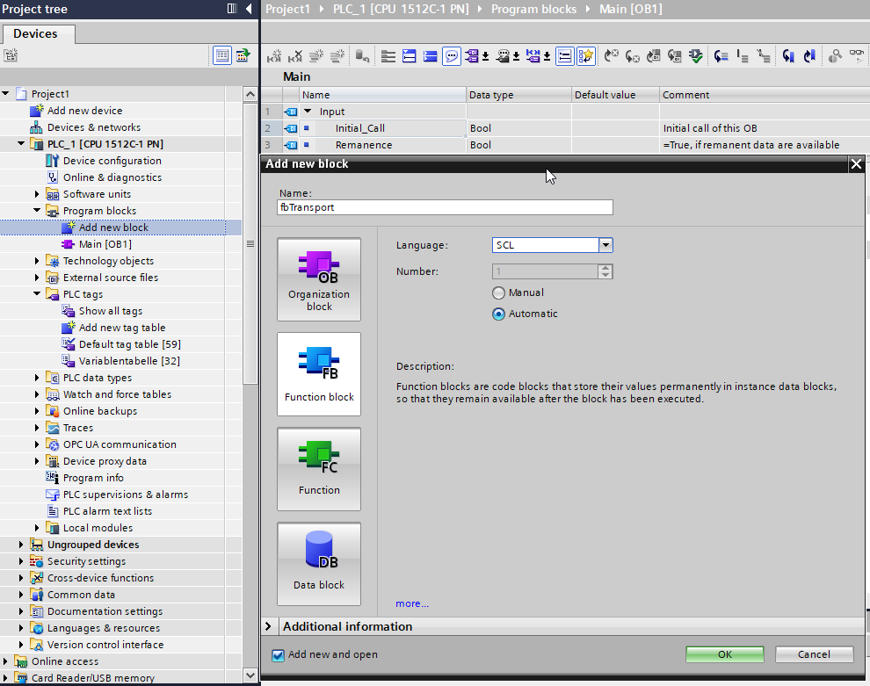
Please select Function block!

Program creation in the function block

Video: 22TIA_FB_Prog

For the first test, a few input and output variables are created and used to write a small PLC program for cylinder 1.
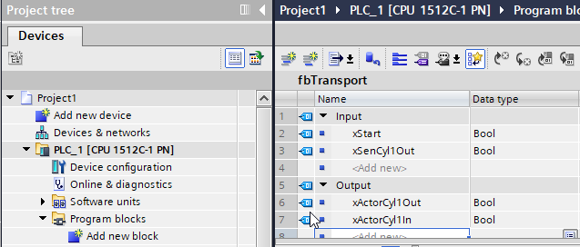

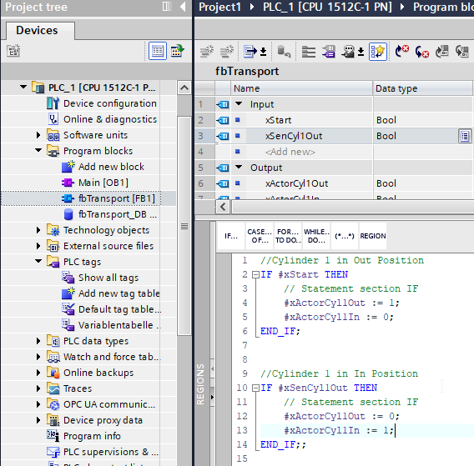

Call the FB in Main OB1 and save the program

Video: 23TIA_Prog_Save

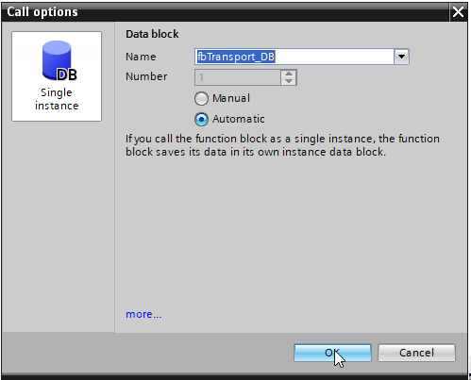
In MAIN OB1, the variables of the function block are linked to the PLC variables (PLC tags). First, the function block must be dragged and dropped into MAIN OB1.
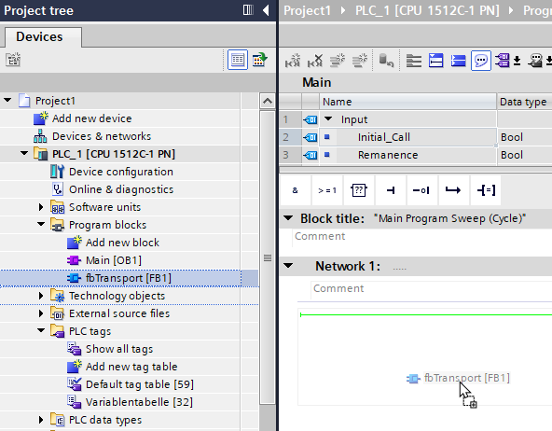

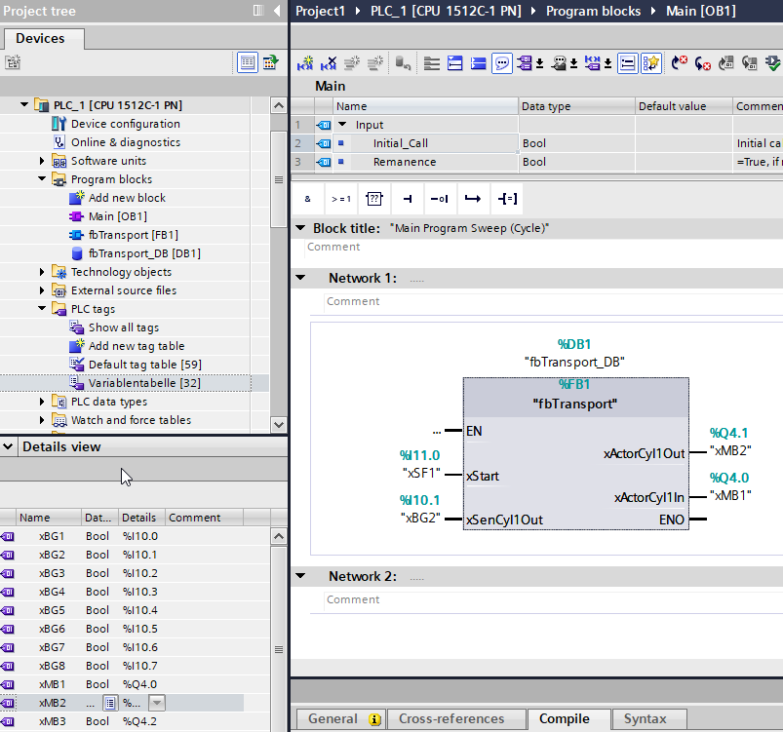

Creating a new simulation instance in PLCSim Advanced

Video: 24_Sim_New_Inst

A virtual soft PLC can be created by starting the PLC Sim Advanced software. This controller, named ditwin01, is used to load the current PLC.
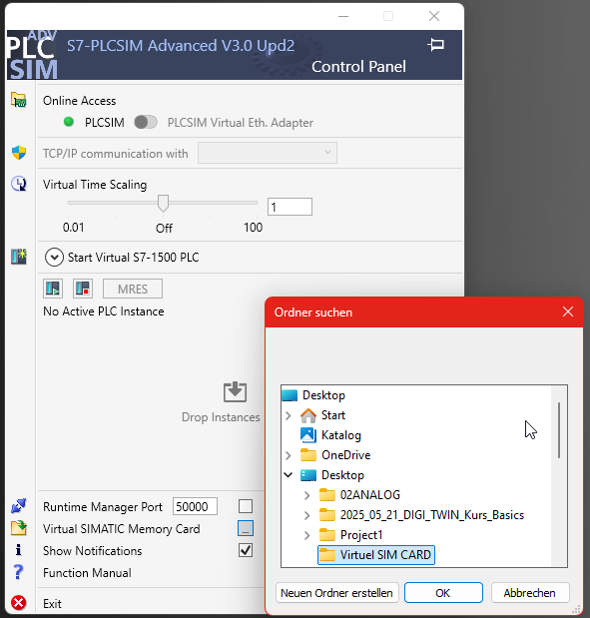#
PLEASE NAME THE SOFT PLC – ditwin01!

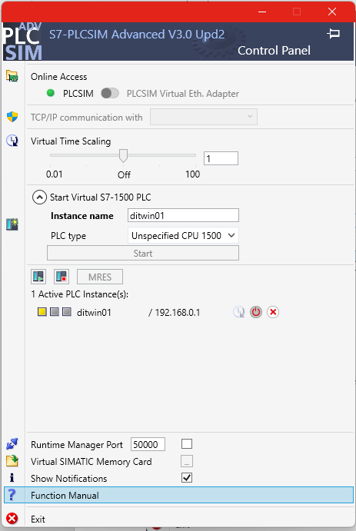
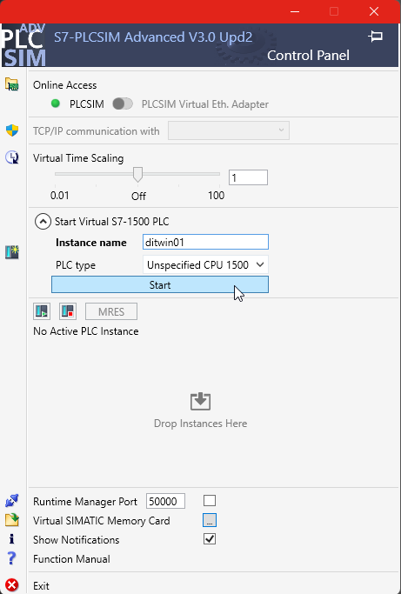

Load TIA program in PLC Sim

Video: 25_TIA_Sim_Transfer

The current PLC program can now be loaded into PLC SIM Advanced.
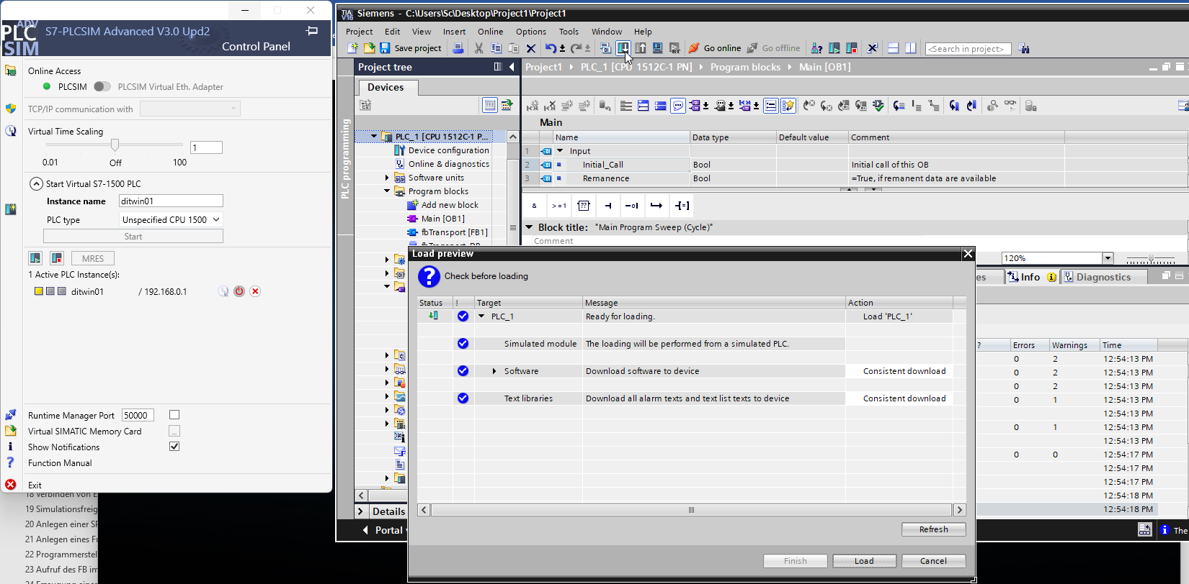
When the module is started, the PLC changes its status from Stop to Start and the LED turns green.
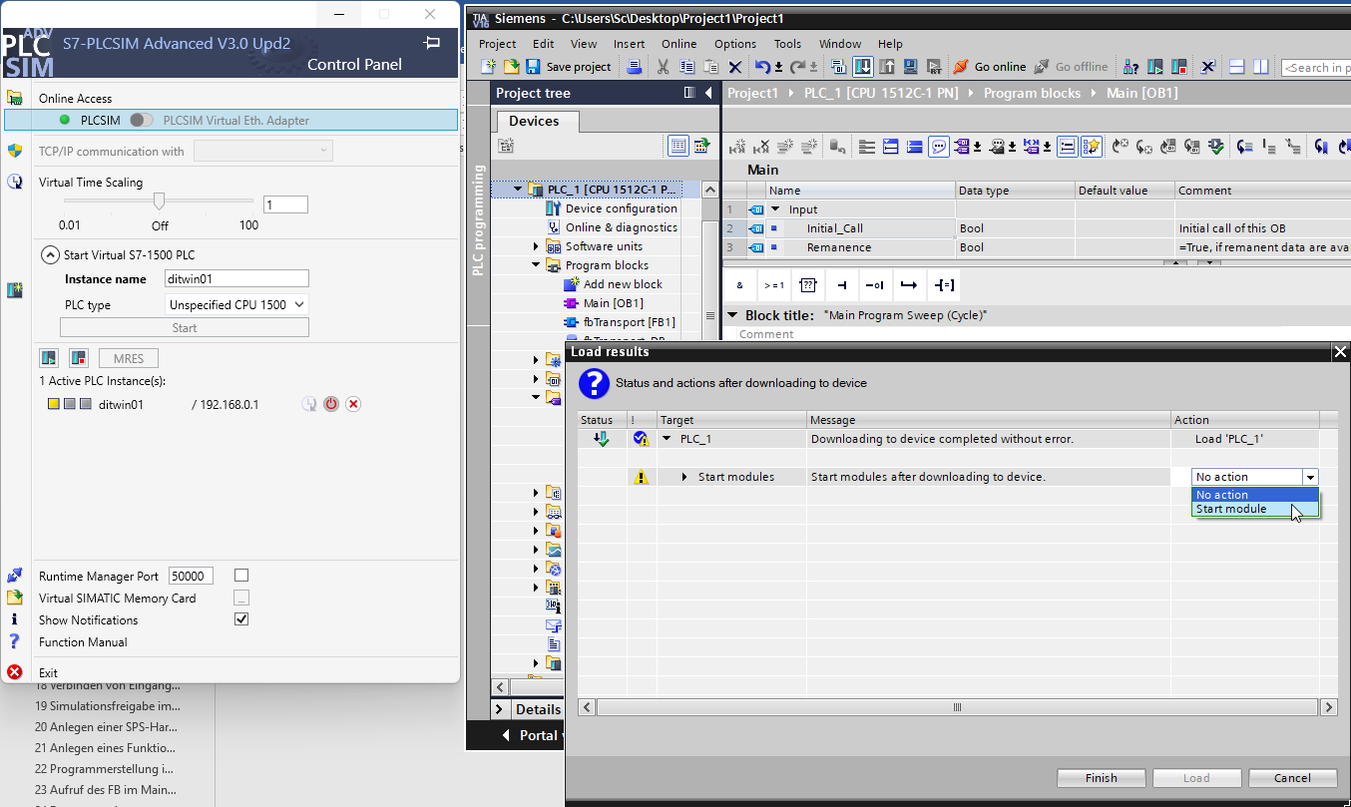
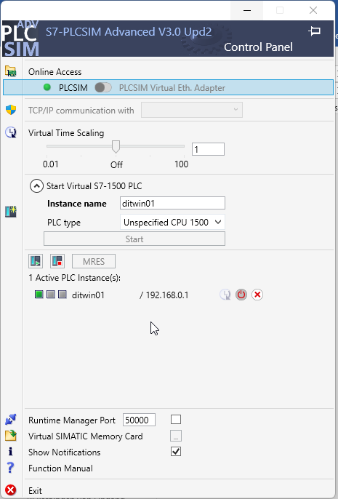

Part 4
4

In this small section we are making some adjustments in NX and we run the test program.

Creating signal connections in MCD

Video: 26_NX_New_Signal_Conn

The simulation level is then ready for operation and the signal connections in Siemens NX MCD must be created.
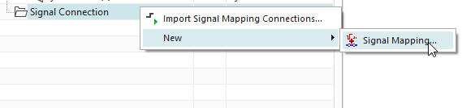
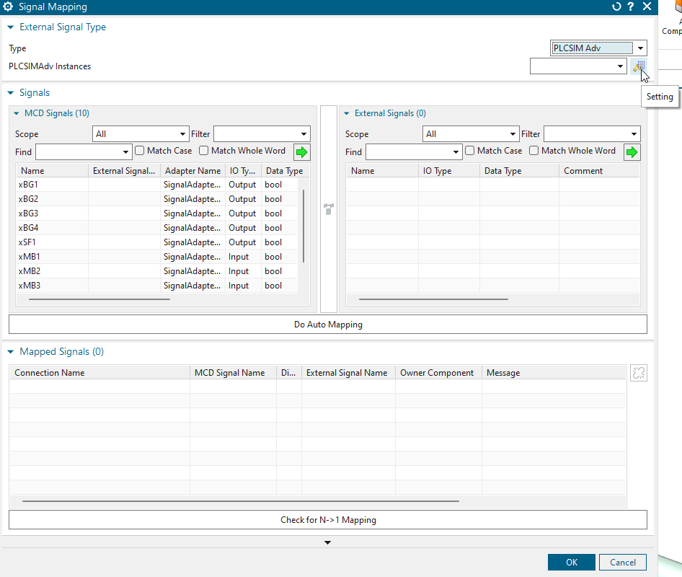
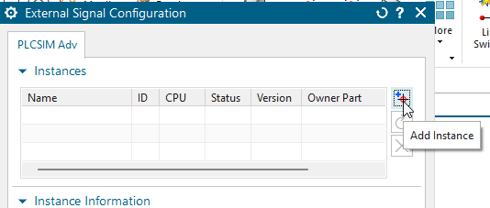

In the signal connections, the soft PLC from PLCSIM Advanced is created as an instance and linked.

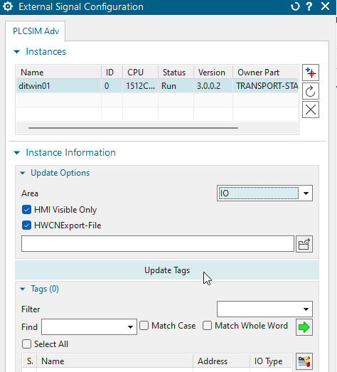
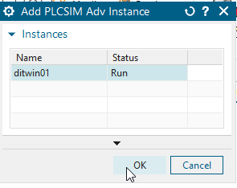

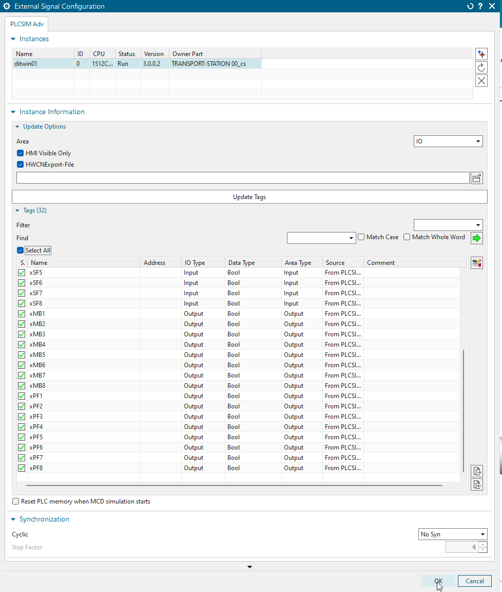
Select all variables and then select automatic assignment. The automatic assignment can be performed successfully thanks to the identical naming.
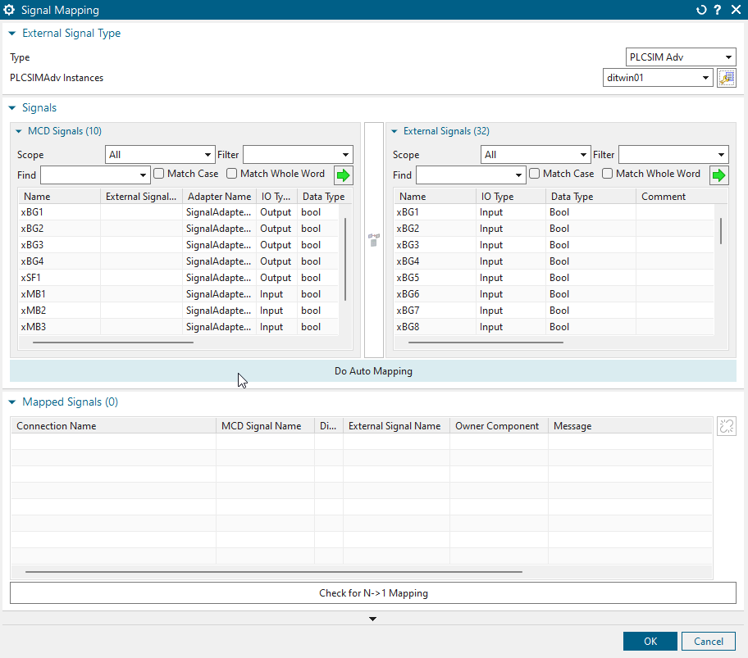

Temporary storage and testing of the software status in NX

Video: 27_NX_Save_Test
Video: 27_TIA_Observe

Testing and observation allow the current status to be simulated and checked.

Testing the software status in the TIA Portal

Video: 28_TIA_Test

The current function block is tested in conjunction with NX MCD and PLCSIM. The variables can also be monitored in observation mode.
Part 5
5

Now we are able to program a „step-chain“ code in TIA Portal and test it with our digital twin model in NX MCD.

Creation of a step chain program

Video: 29_TIA_Step_Chain
In the next step, the small PLC program for cylinder 1 will be overwritten and replaced by a more comprehensive control program with a step chain.
To do this, new variables must be implemented in the function block in the inputs and outputs area. In addition, the step number with the designation istep, which has the default value 0, is added to the static variables area.
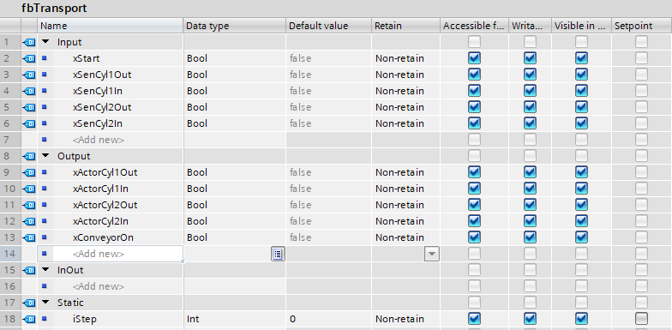
A possible implementation of the step chain in SCL could look like the screenshot below.
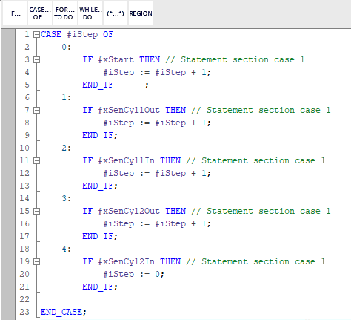

Control of the outputs of the step chain program

Video: 30_TIA_New_Prog_Chain

After the advance conditions were defined in the previous step, the control of the outputs is now defined in the program.
To do this, only the step numbers are assigned to the individual outputs and connected using a basic logical OR (OR) link.
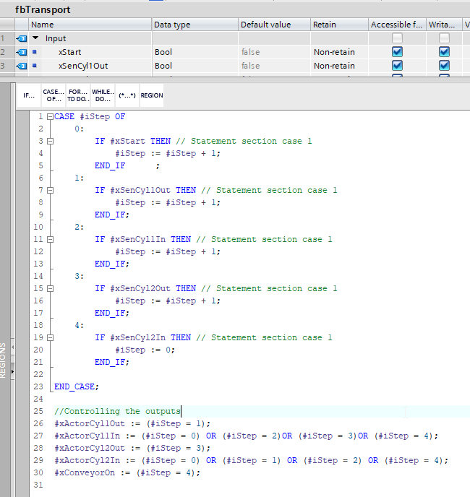
The adjustments in the function block also require adjustments to be made in the MAIN OB1 block with regard to variable assignment.
To do this, the content in MAIN OB1 must first be updated so that the PLC variables can then be reassigned.
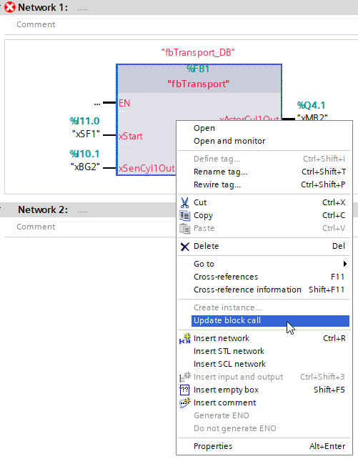
Simply click on Show all tags once and assign them to MAIN OB1 using drag & drop.
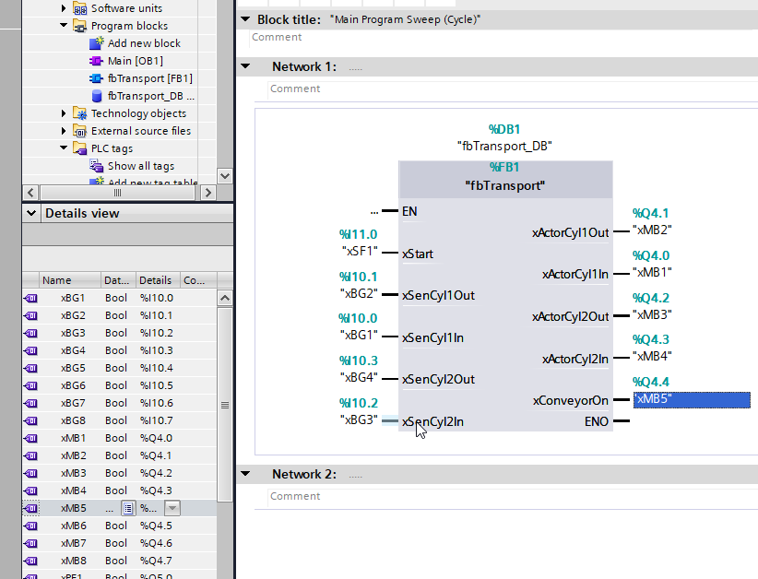
The current software version can then be reloaded from the TIA Portal into the soft PLC in PLCSIM Advanced.
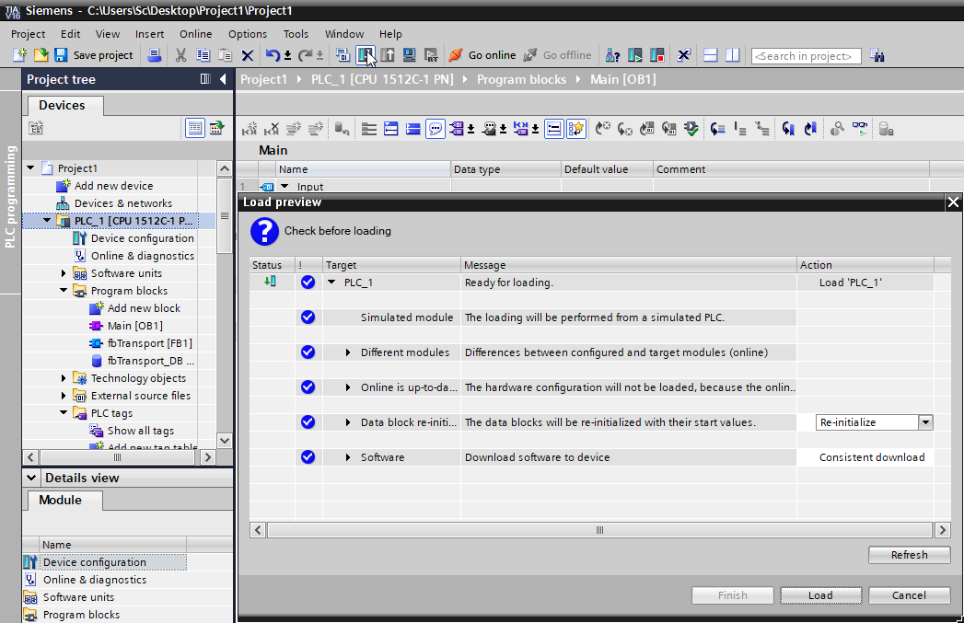

Testing the software version with NX

Video: 31_NX_Prog_Chain_Test

Finally, the newly programmed step chain can be tested with the NX model. To do this, first start the simulation (RUN) and press the Start button.
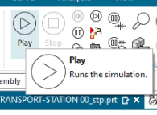
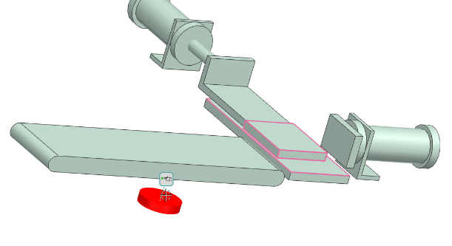
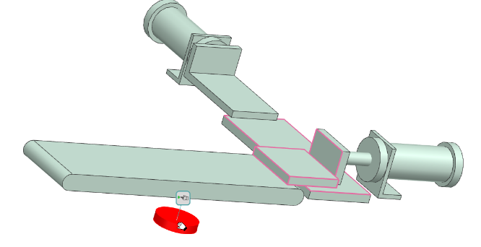

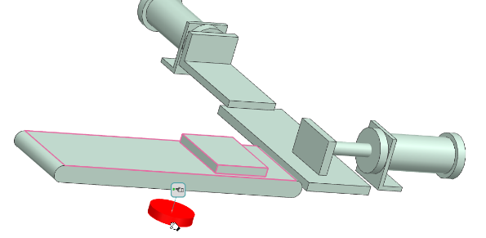

Save status and close entire project

Video: 32_Save_Close_All

Finally, all project statuses should be saved so that variations and adjustments can be made afterwards.
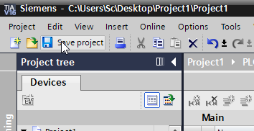
The TIA Portal project can then be closed.
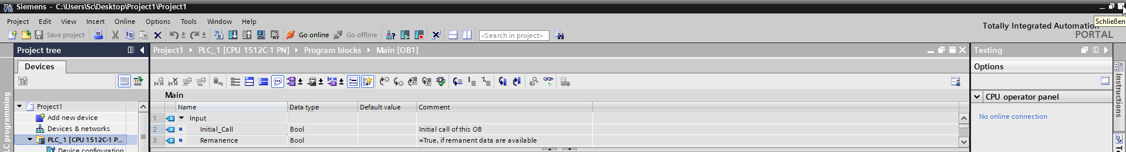

To close PLC SIM Advanced properly, it is best to proceed as shown.
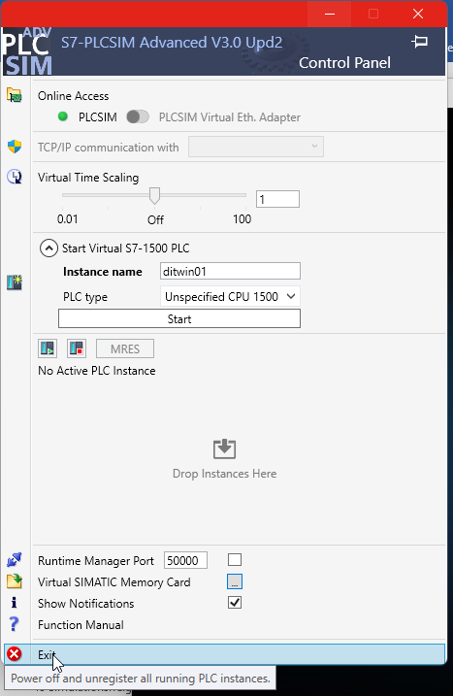
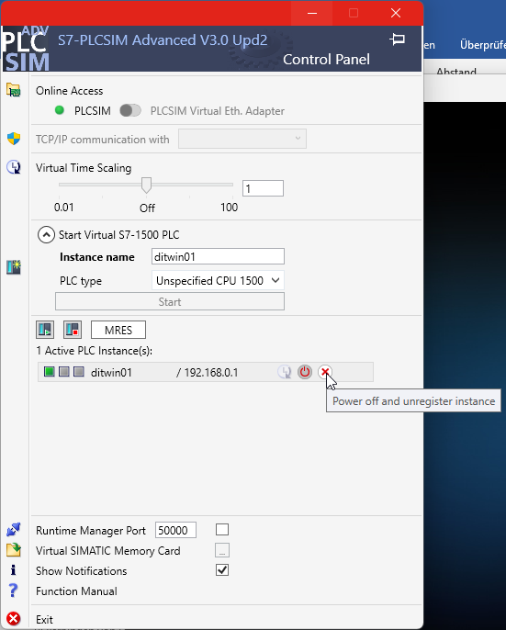

Reopen the SimCaer virtual PLC

Video: 33_SIM_reopen-Simcard

In this exercise, the virtual controller, or rather the SIM card within it, is to be restarted. To do this, Siemens PLCSIM Advanced is opened, and the SIM card is dragged back into the designated slot. Afterwards, the PLC can be started again.

Reopen the NX simulation project

Video: 34_NX_reopen-Simulate

After the Soft-PLC is operational again, the NX program can be reopened. To do this, the corresponding file is opened—this is a part file for the conveyor belt—which allows the simulation to be started again.

Integration of a stop button in the NX simulation

Video: 35_NX_Stop-Button

In the simulation, an additional button is to be integrated. This button should be placed next to the start button and will later function as a stop button.

Integration of a text description in NX

Video: 36_NX-Text

The button should be labeled in the same way as the start button. For this purpose, a corresponding label can be attached to the respective button so that the machine operator can later identify which functions are assigned to each button.

Embed the function runtime button for the stop signal

Video: 37_NX-Stop-Signal

In this step, the function of a runtime button is to be assigned to the stop button as well. This is carried out in the same way as for the start button, following the procedure shown in the video.

Adjustment for the stop signal in the signal adapter

Video: 38_NX-Change-Signal-Adapter

For the stop button, minor adjustments must subsequently be made in the signal adapter. In this case, the stop button must be declared as an output, since a sensor in the simulation assumes the function of an output.

Adjustment for the stop signal in the signal connection

Video: 39_NX-Change-Signal-Conn

For communication, the new stop button labeled SF2 must also be assigned to the TIA program in the Signal Connection. This assignment is carried out within the Signal Connection.

Adjustments in the TIA Program for the stop signal

Video: 40_TIA-Change-Prog

In this step, the hardware-related adjustments for the stop button are to be integrated into the TIA Portal program. For this purpose, the function block is called, and the modifications are implemented using a new variable for the stop button.
To integrate the operating state, an additional static variable is required in the Static section to represent the state of the machine or process. This variable is designated as xENABLE.

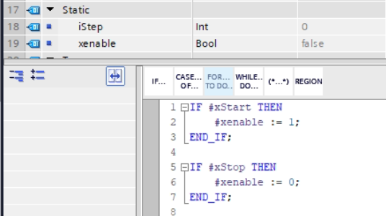

Environment test of the stop button in the NX simulation

Video: 41_NX-Test-Stop

In the next step, the modification and integration of the stop button are tested in the simulation using Siemens NX Mechatronics Concept Designer. To do this, the simulation is started via the Run button, and it is tested whether the process stops when pressing the second button.

Integration of two new collision sensors in the NX simulation

Video: 42_NX-New-Coll-Sensors

In this step, two new collision sensors are integrated into the MX model. One collision sensor is positioned in the middle of the conveyor belt, and another at the end of the belt at workpiece height, to monitor the conveyor system. The collision sensors will later be used in the process sequence to provide feedback on the workpieces located on the conveyor belt.

Adjustment for the collision sensors in the signal adapter

Video: 43_NX-Signal-Ad-conn

In this step, the two new sensors are linked with their respective parameters in the signal adapter to enable communication. Since they are sensors, they are treated as outputs in the simulation and are parameterized accordingly in the signal adapter.

Integration of a source and sink for the production parts

Video: 44_NX-Source-Sink

In the next step, the workpiece is defined as a source. This means that a new workpiece repeatedly appears at the workpiece position. In other words, the source regularly generates a new workpiece when triggered, for example by pressing the start button, to keep the process running continuously.
Subsequently, a sink is defined where the workpieces disappear after reaching it. This ensures a continuous flow, where a new workpiece is introduced while another one automatically disappears at the end of the process. This principle is also referred to as source and sink.

Adjustment for workpiece source in the signal adapter

Video: 45_NX-Internal-Signal_Adapter

In the further course, the object source is integrated into the signal adapter in order to control the workpieces and their appearance.

Adjustment for a rising edge in the signal adapter

Video: 45_NX-rising-edge

In order for the components to disappear at the workpiece sink, a setting must be configured in the signal adapter. This setting is based on a rising edge, which must be assigned to the corresponding parameter. The required adjustments can be followed in the video, where the appropriate configuration is carried out in the signal adapter using the “Rising Edge” command.

Disclaimer
Funded by the European Union. Views and opinions expressed are however those of the author(s) only and do not necessarily reflect those of the European Union or the European Education and Culture Executive Agency (EACEA). Neither the European Union nor EACEA can be held responsible for them.

